# AI ASSISSTED CODING ASSIGNMENT 11.1

NAME:HARINI

Batch no:05

ROLLNO:2403A510E1

**COURSE:** AI assissted coding

**• Enhance code quality with AI-generated comments and performance  
suggestions.**

**Task Description #1 –**

Stack Implementation  
Task: Use AI to generate a Stack class with push, pop, peek, and is_empty  
methods.  
Sample Input Code:  
class Stack:  
pass  
Expected Output:  
• A functional stack implementation with all required methods and  
docstrings

**PROMPT:**

generate a Stack class with push, pop, peek, and is_empty  
methods. **.**

**Code:**

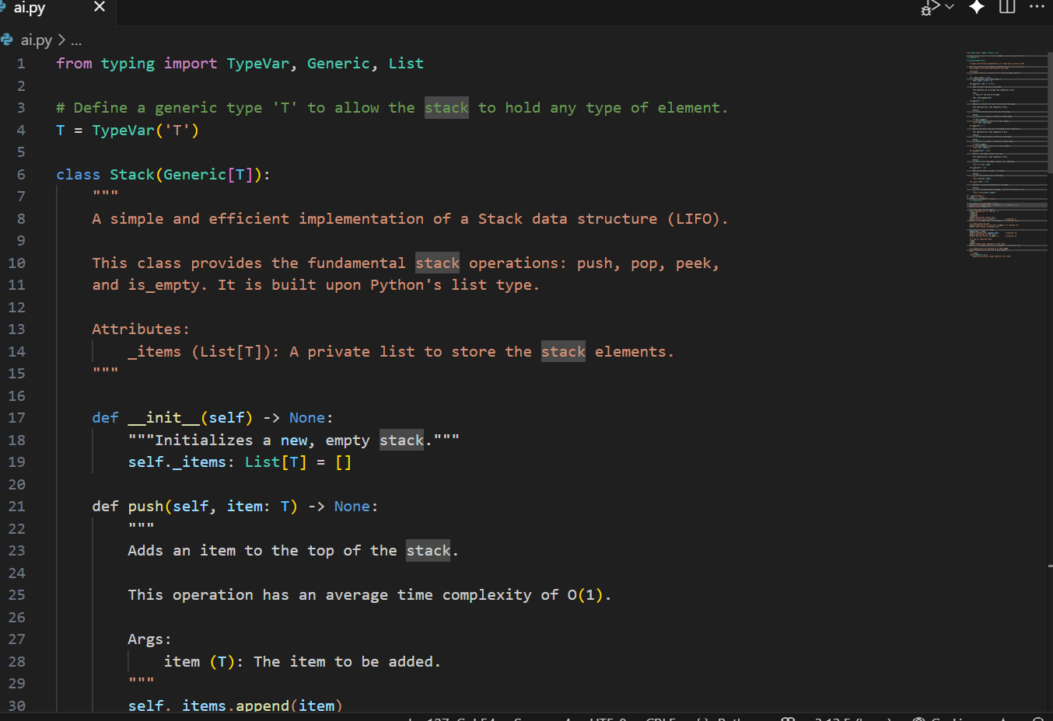

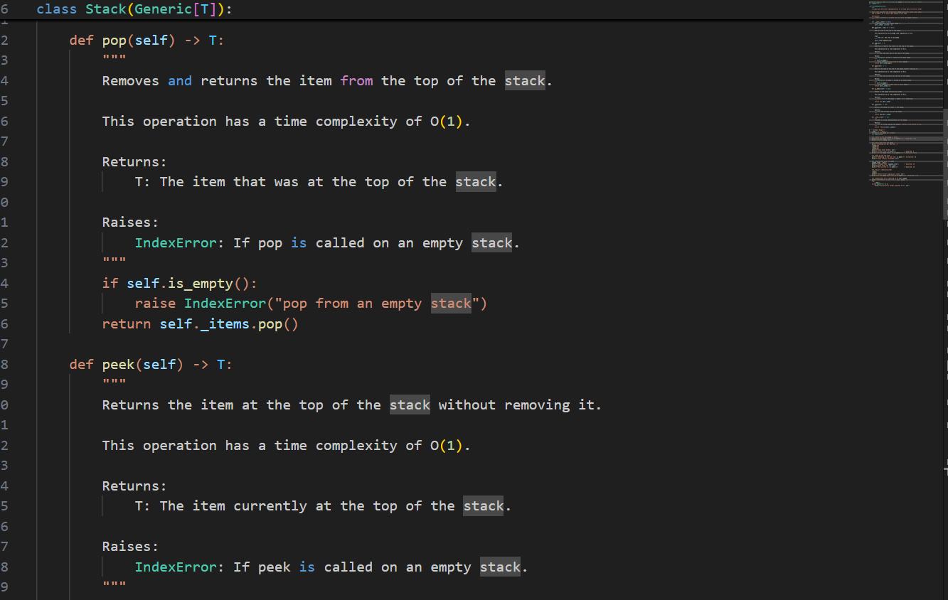

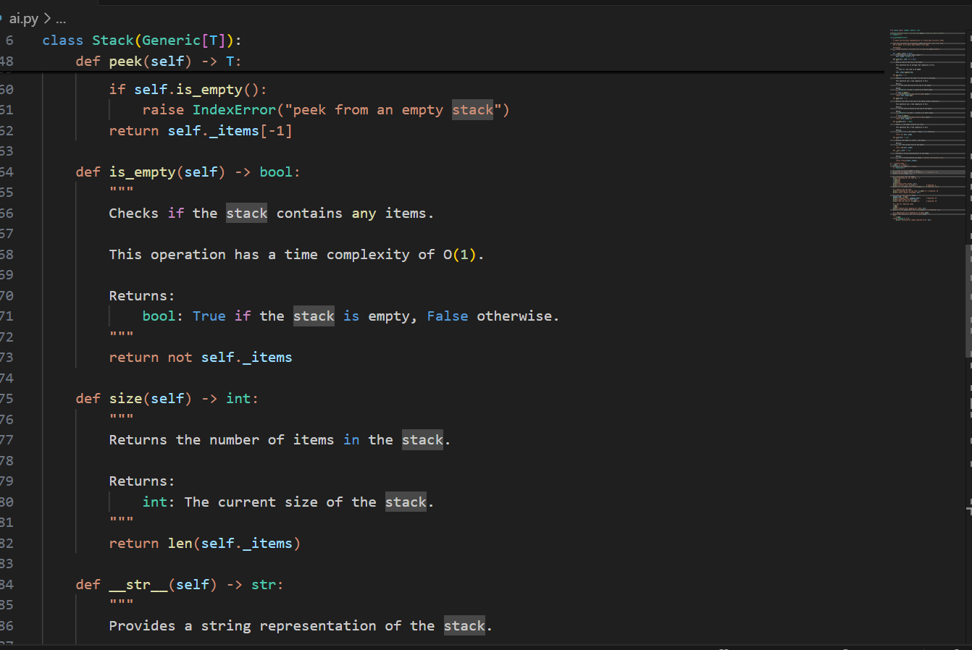

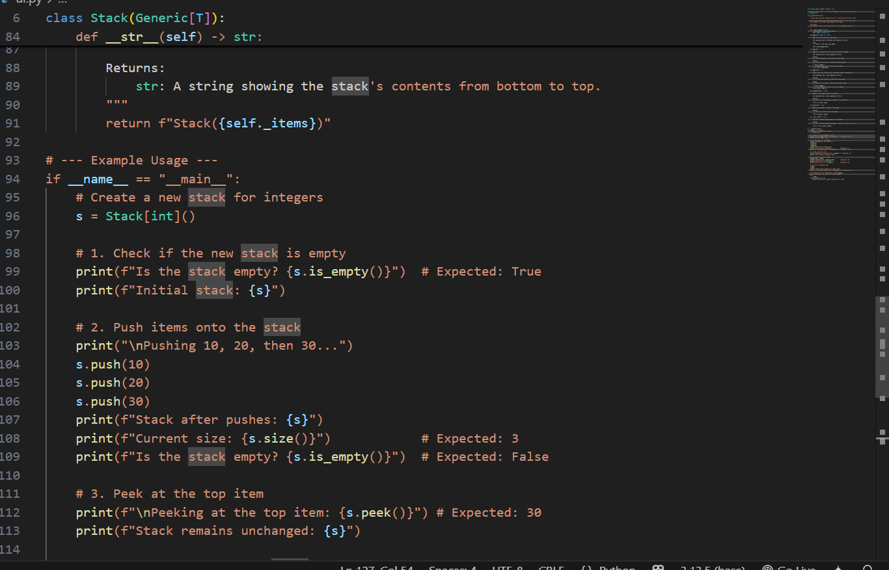

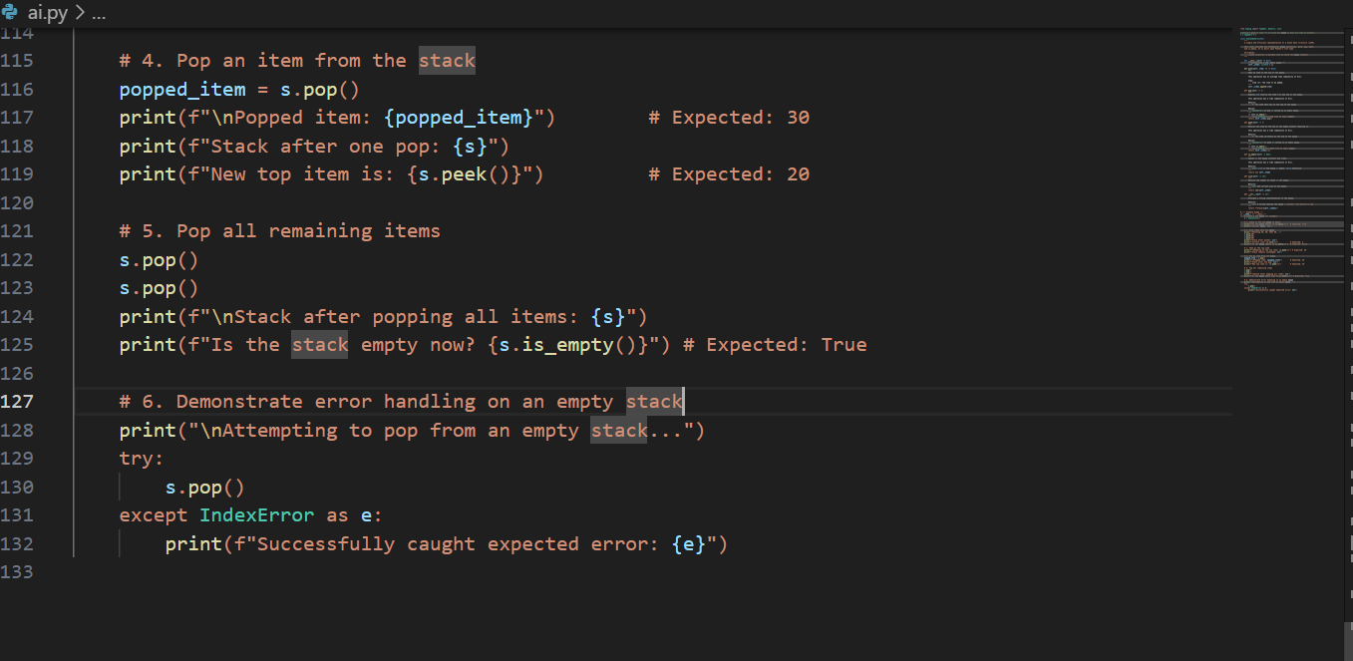

**Output:**

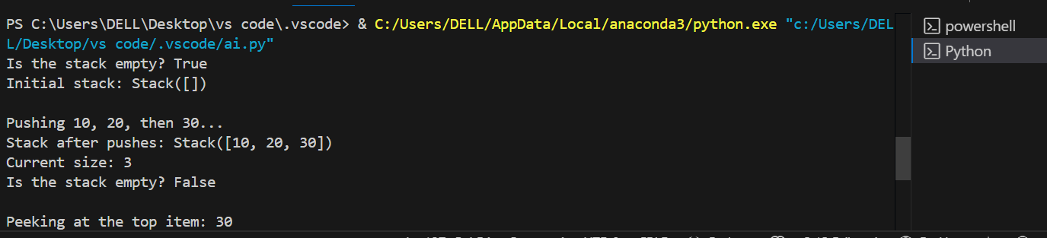

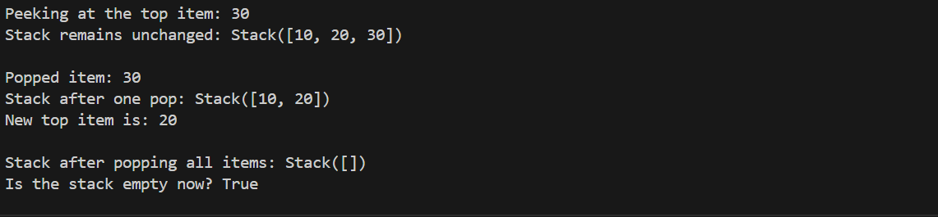

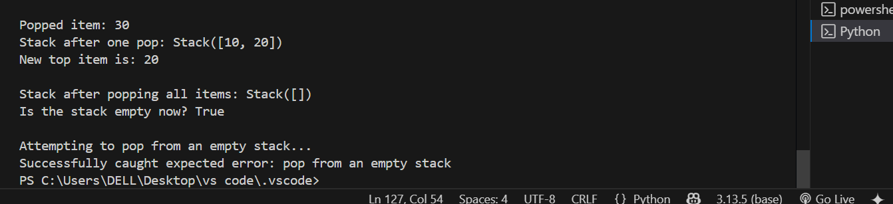

**Observations:**

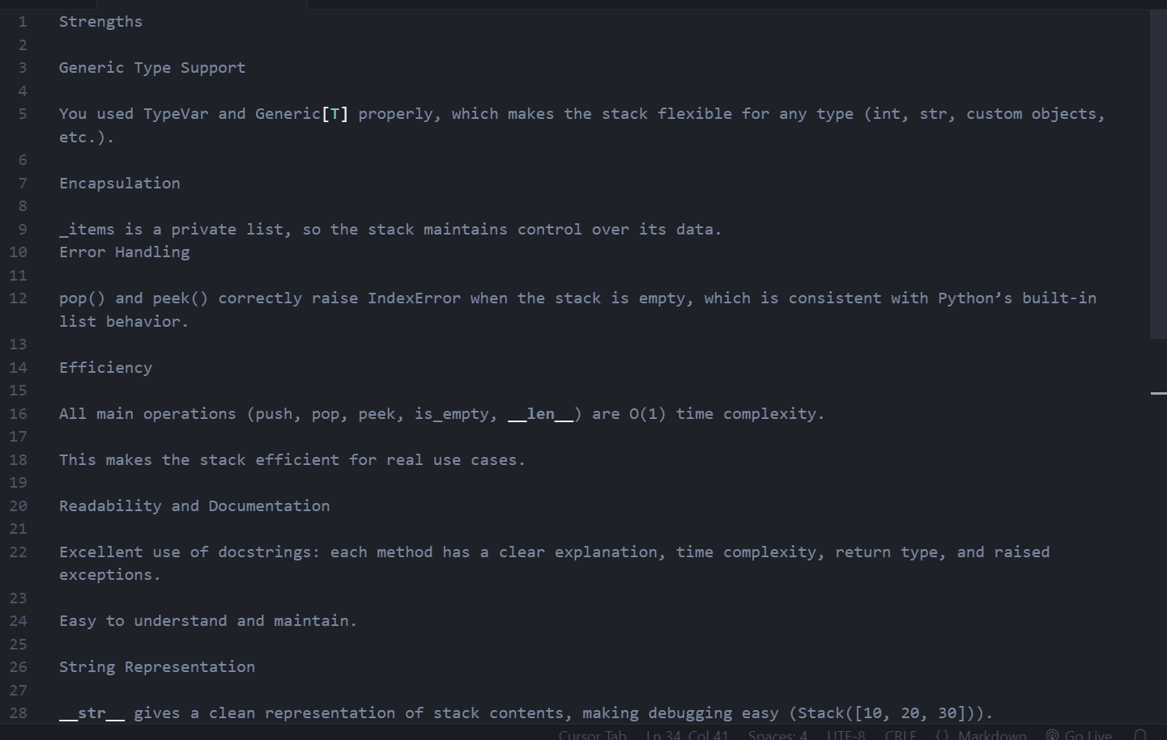

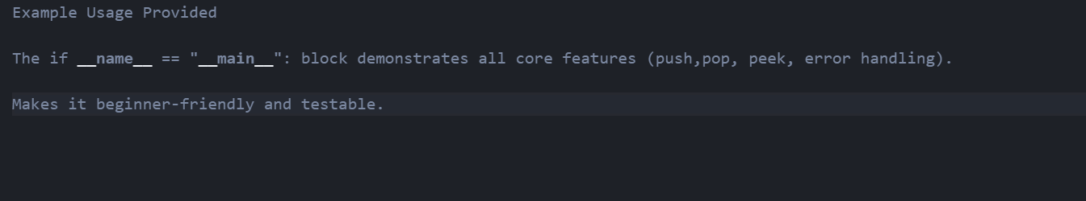

**Task Description #2** –

Queue Implementation  
Task: Use AI to implement a Queue using Python lists.  
Sample Input Code:  
class Queue:  
pass  
Expected Output:  
• FIFO-based queue class with enqueue, dequeue, peek, and size  
methods.

**PROMPT:**

implement a Queue using Python lists

**Code:**

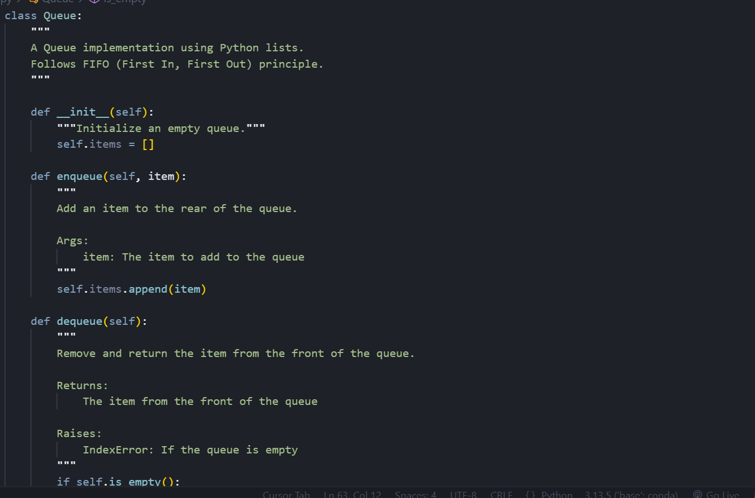

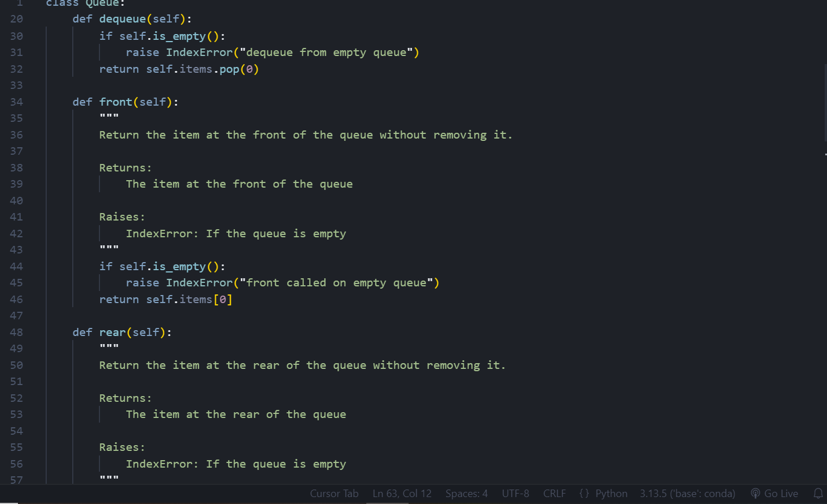

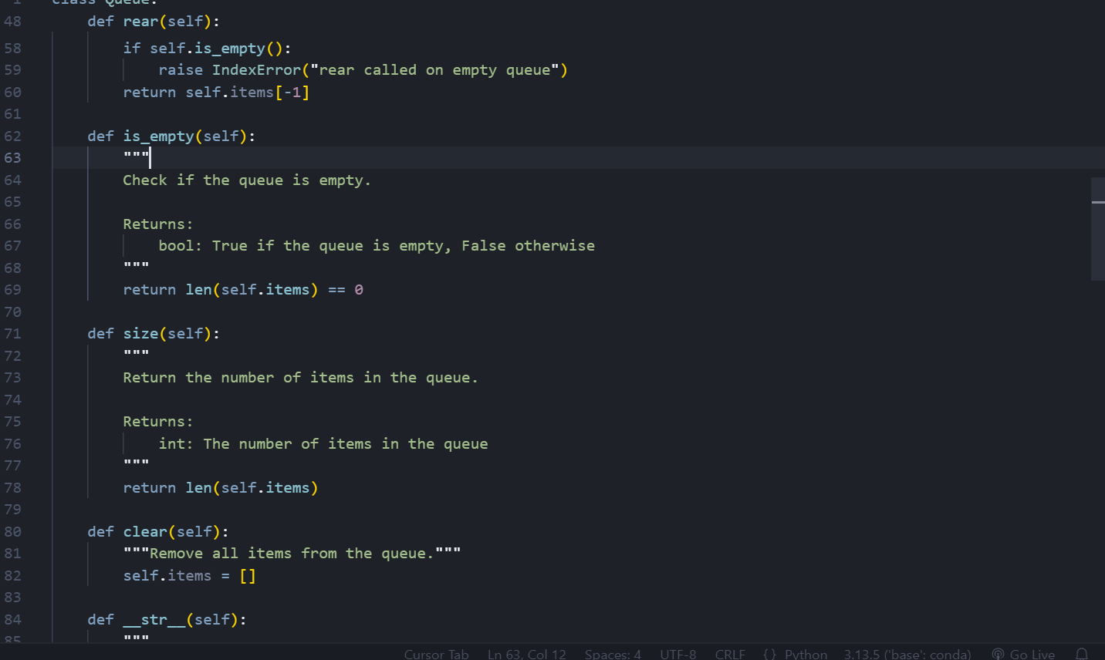

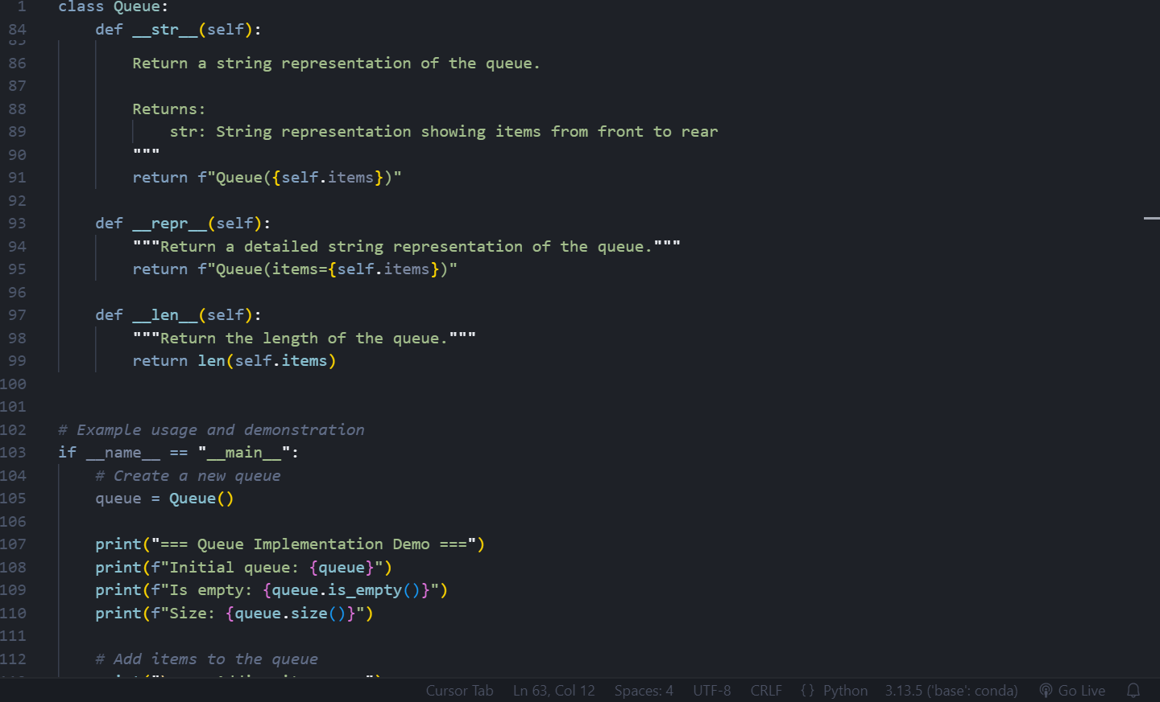

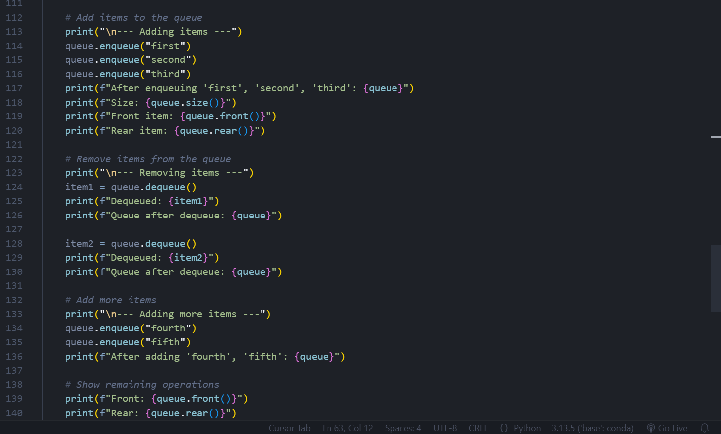

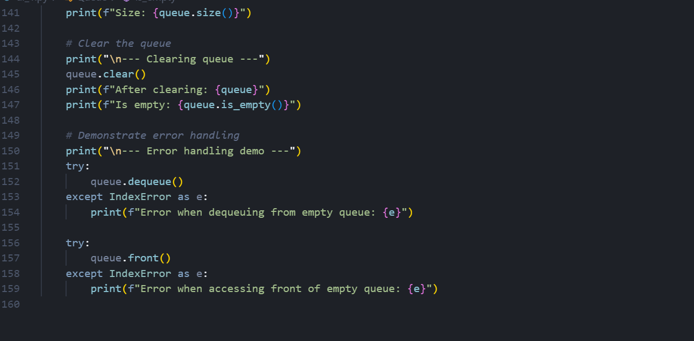

**Output:**

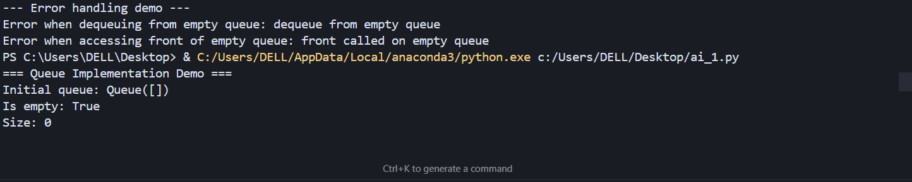

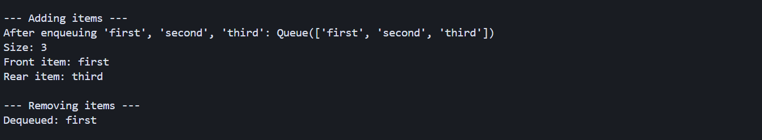

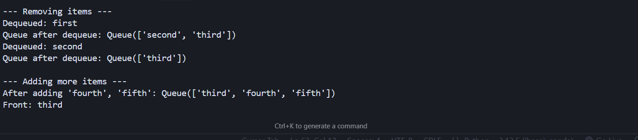

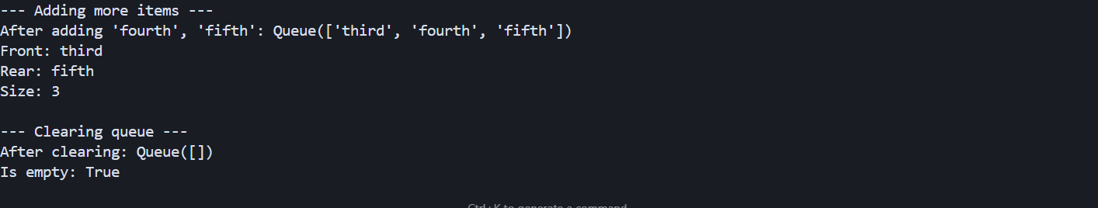

**Observation:**

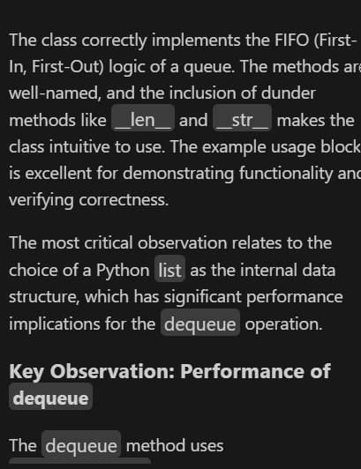

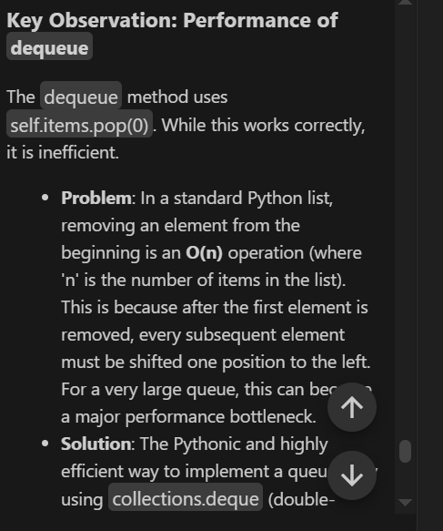

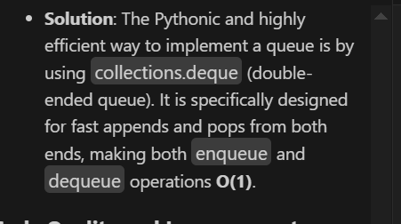

**Task Description #3** –

Linked List  
Task: Use AI to generate a Singly Linked List with insert and display methods.  
Sample Input Code:  
class Node:  
pass  
class LinkedList:  
pass  
Expected Output:  
• A working linked list implementation with clear method  
documentation.

**Code:**

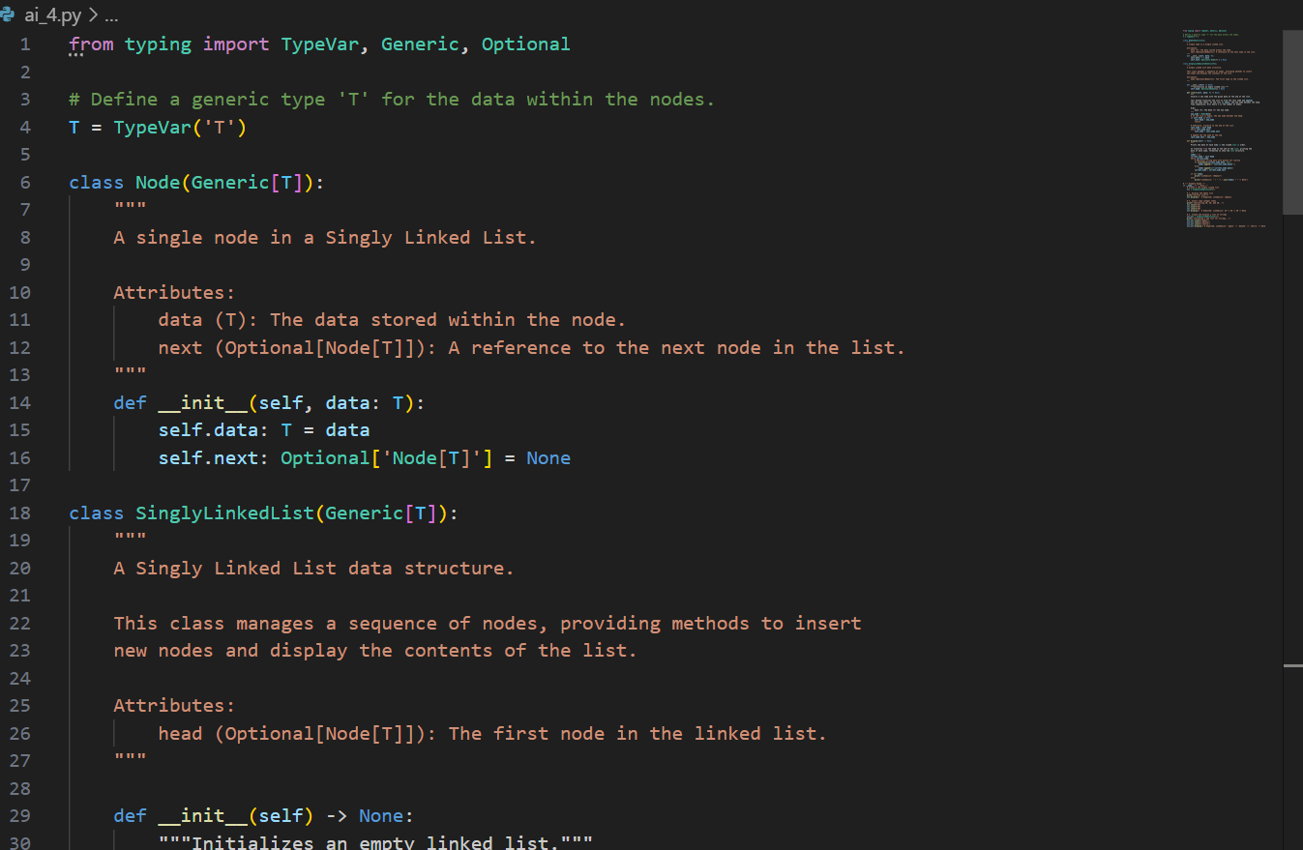

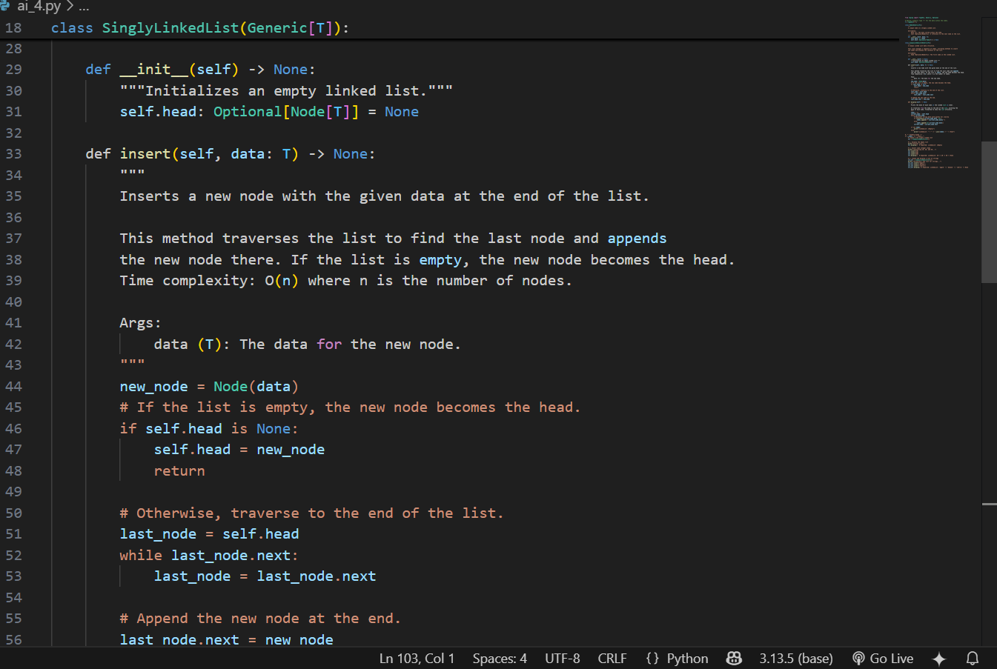

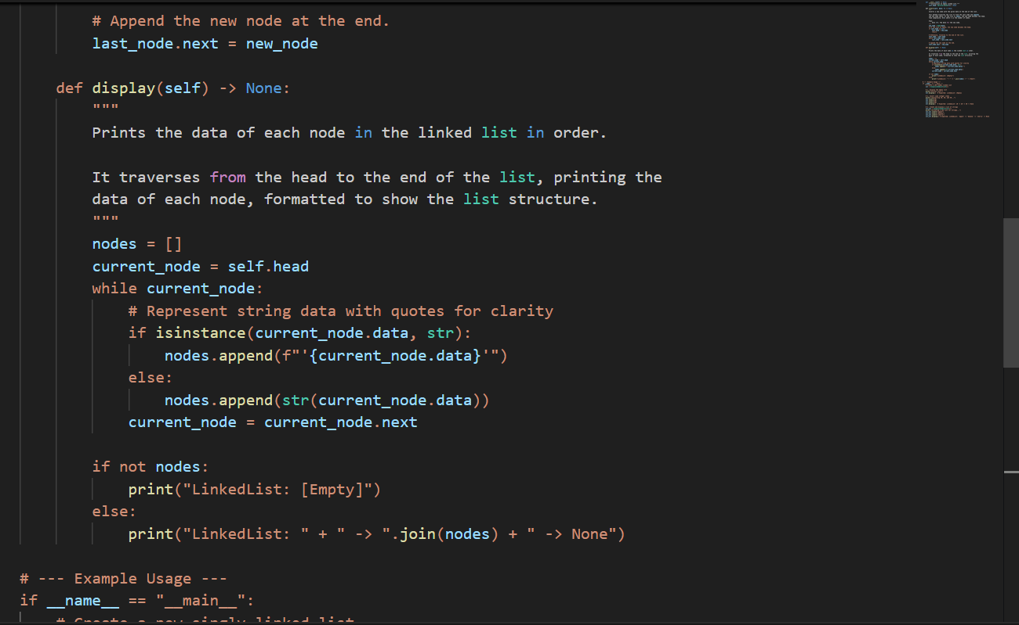

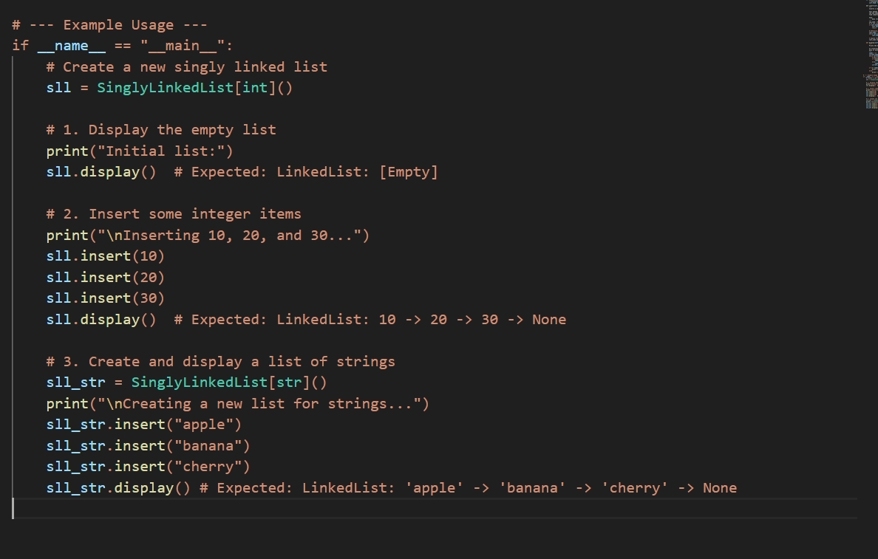

**Output:**

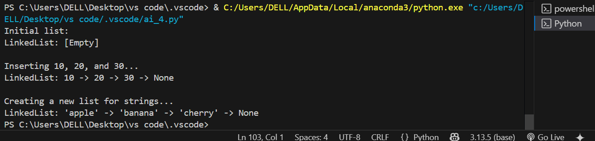

**Observations:**

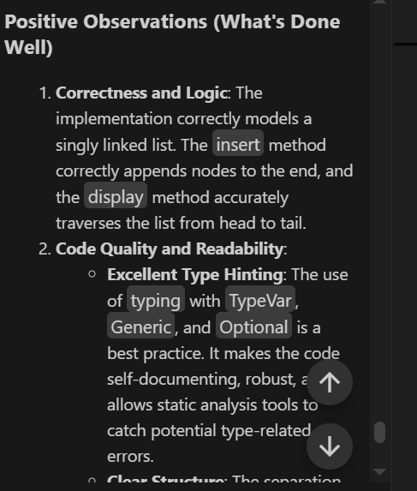

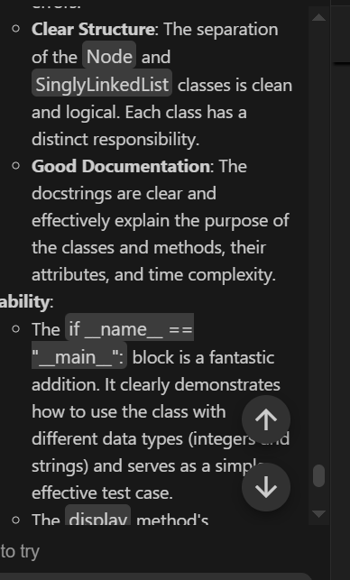

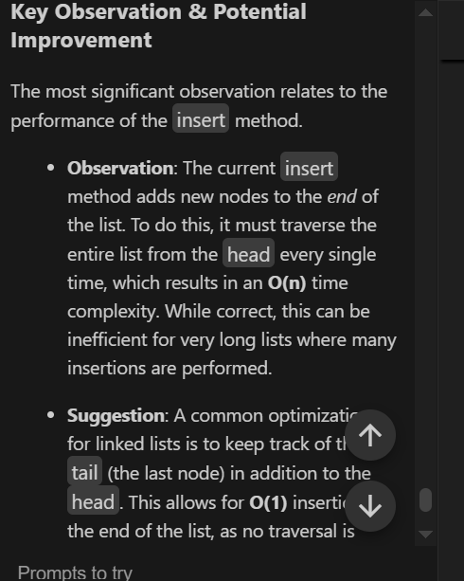

**Task Description #4** –

Binary Search Tree (BST)  
Task: Use AI to create a BST with insert and in-order traversal methods.  
Sample Input Code:  
class BST:  
pass  
Expected Output:  
• BST implementation with recursive insert and traversal methods.

**PROMPT:**

create a BST with insert and in-order traversal methods.

**Code:**

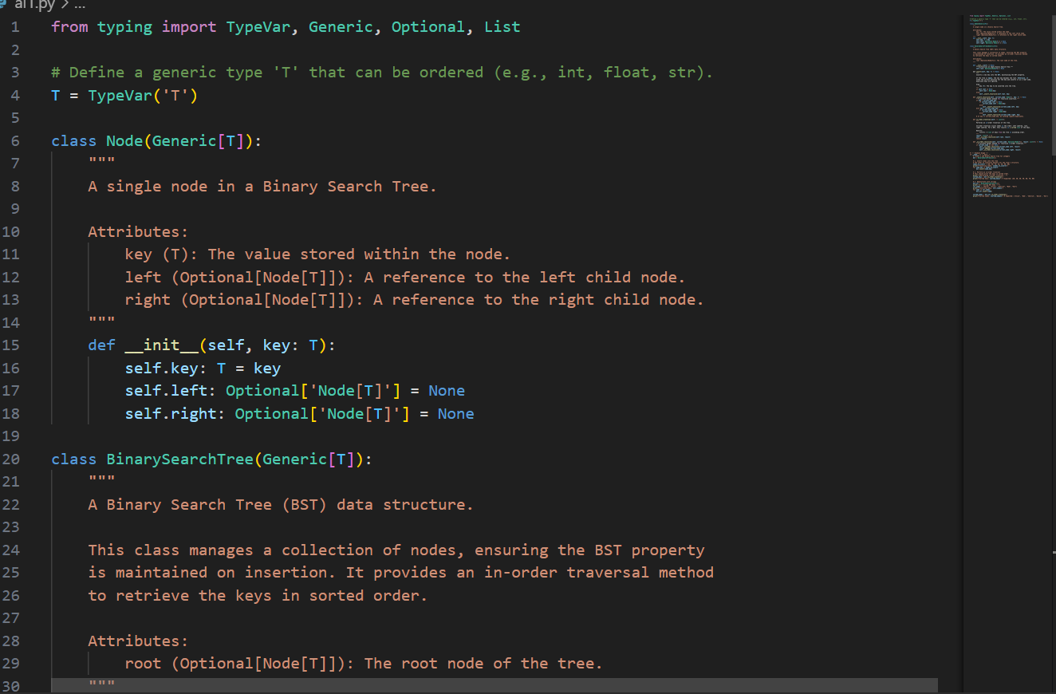

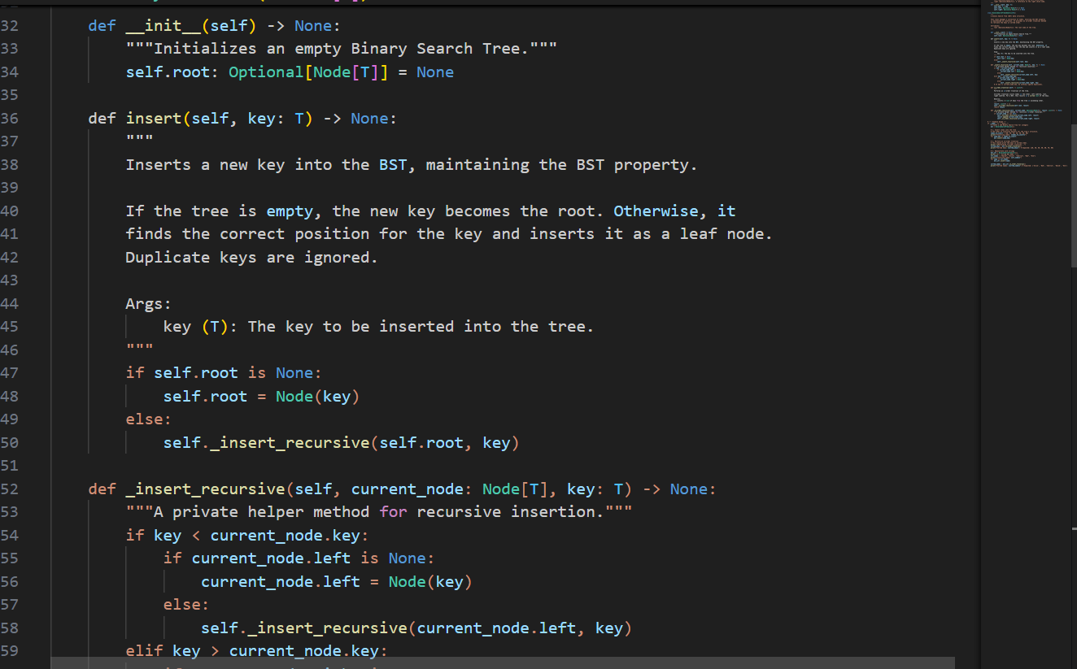

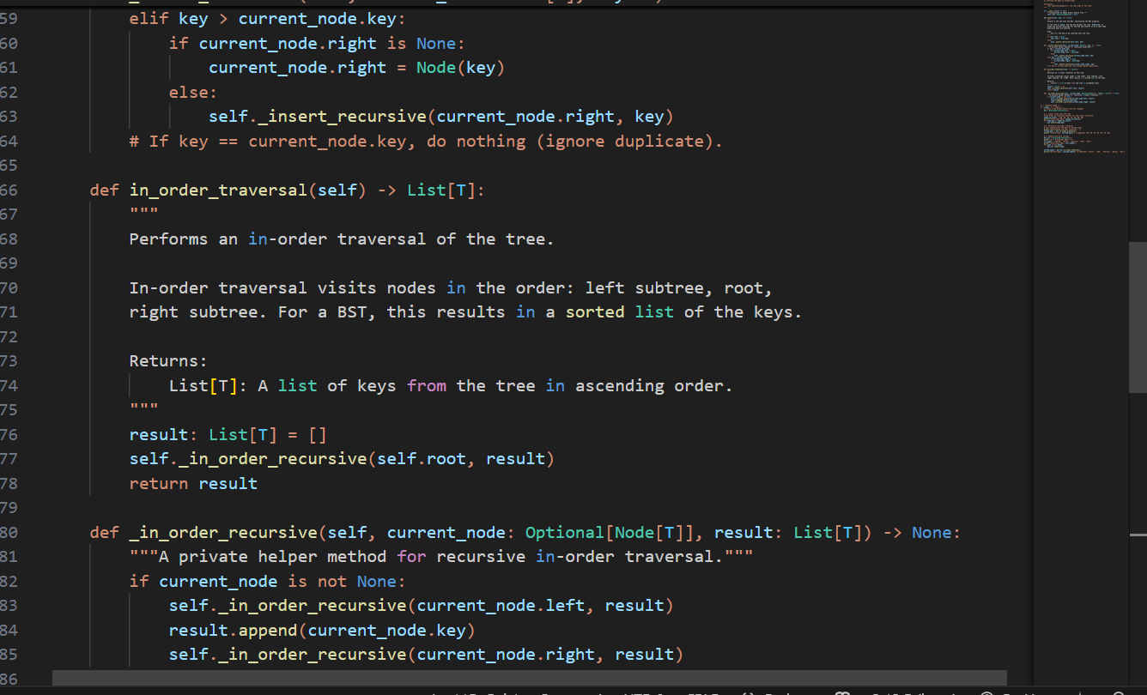

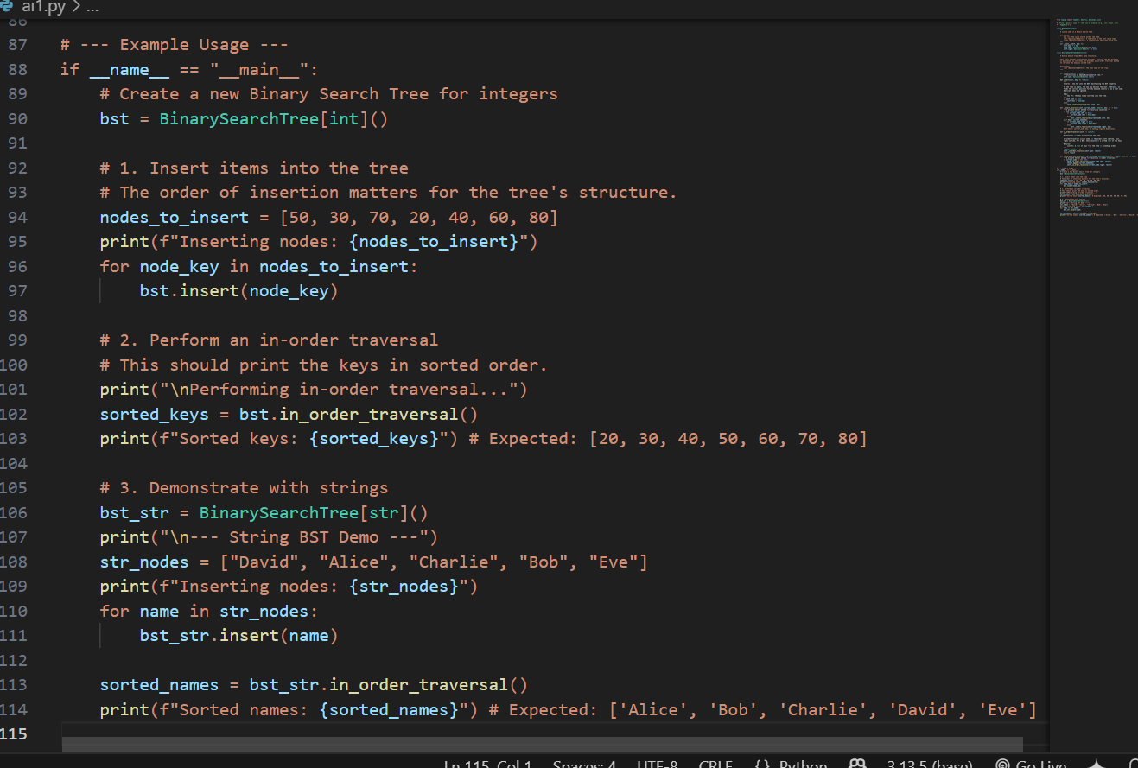

**Output:**

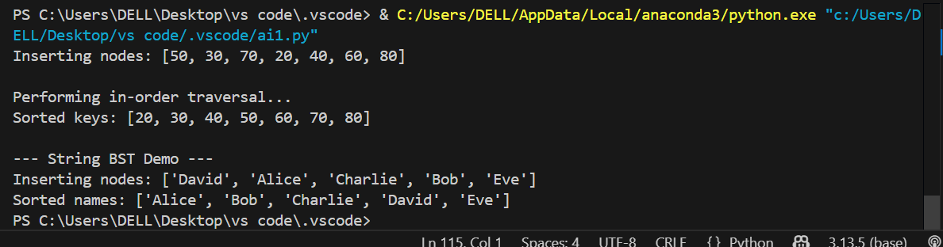

**Observations:**

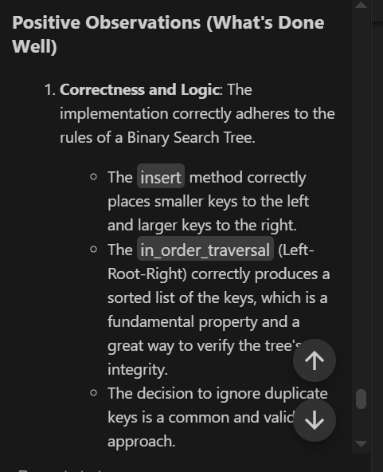

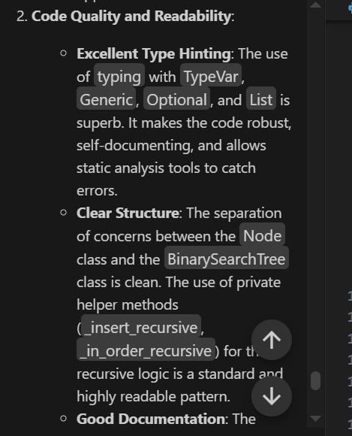

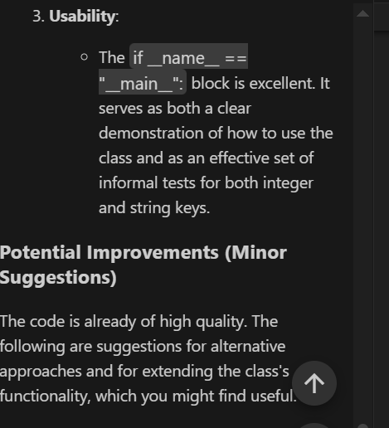

**Task Description #5** –

Hash Table  
Task: Use AI to implement a hash table with basic insert, search, and delete

methods.  
Sample Input Code:  
class HashTable:  
pass  
Expected Output:  
• Collision handling using chaining, with well-commented methods.

**PROMPT:**

implement a hash table with basic insert, search, and delete

methods.

**Code:**

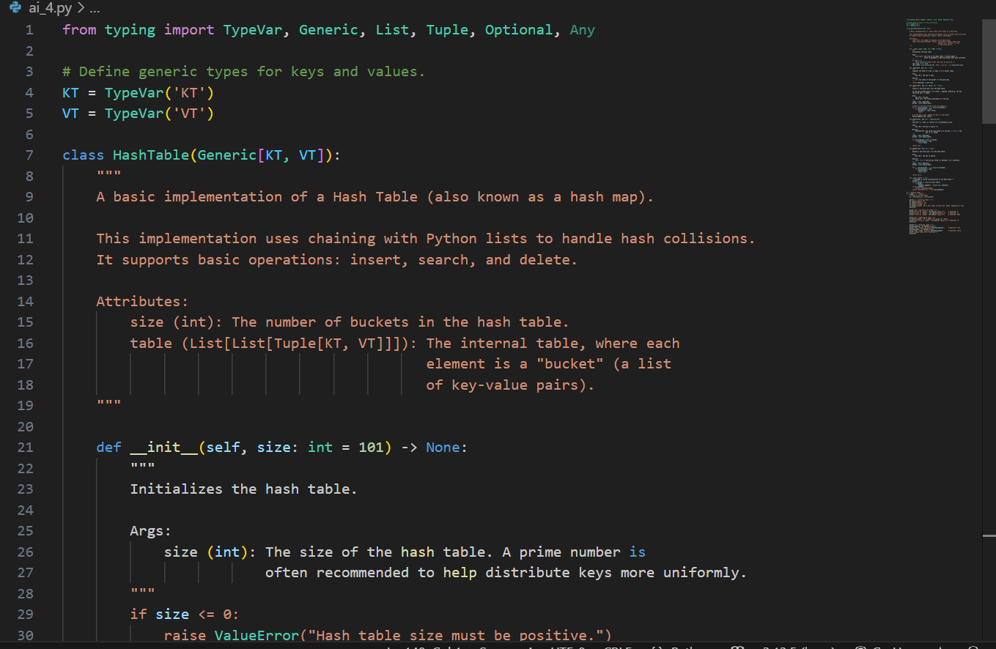

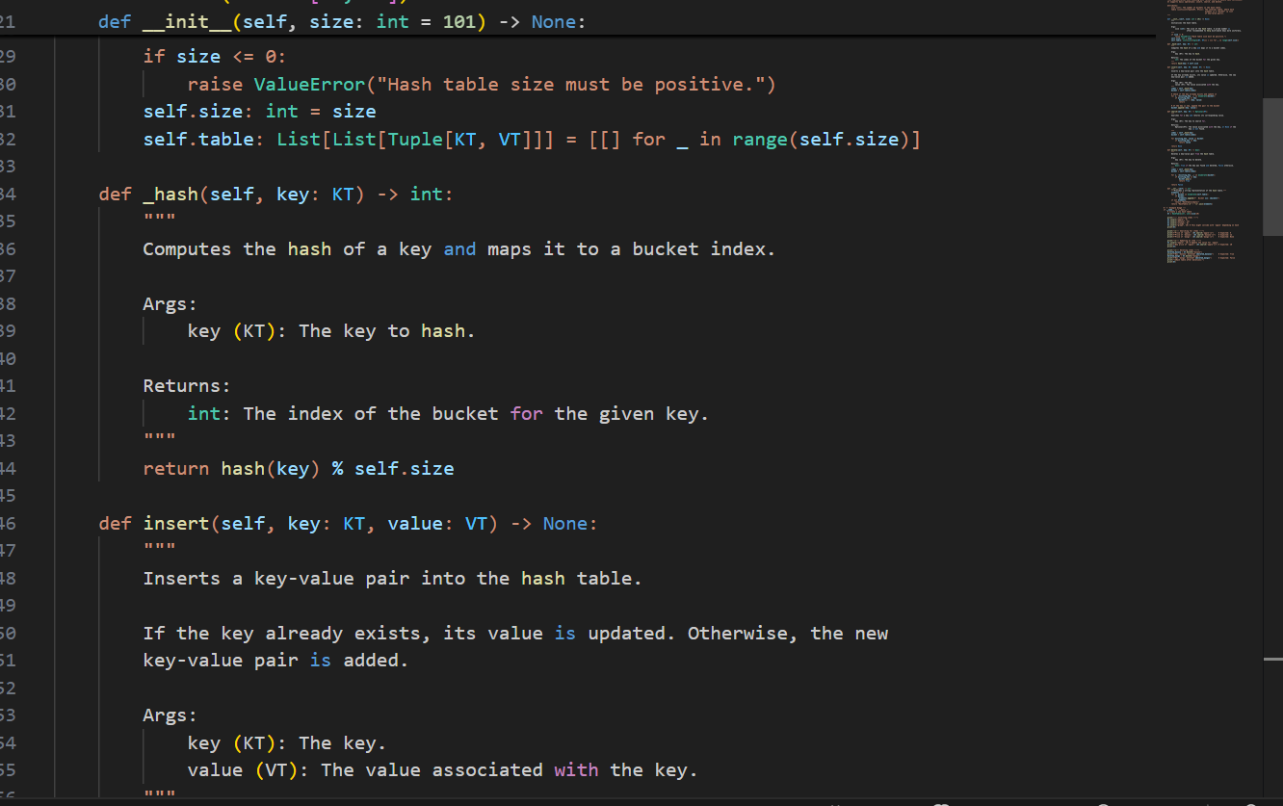

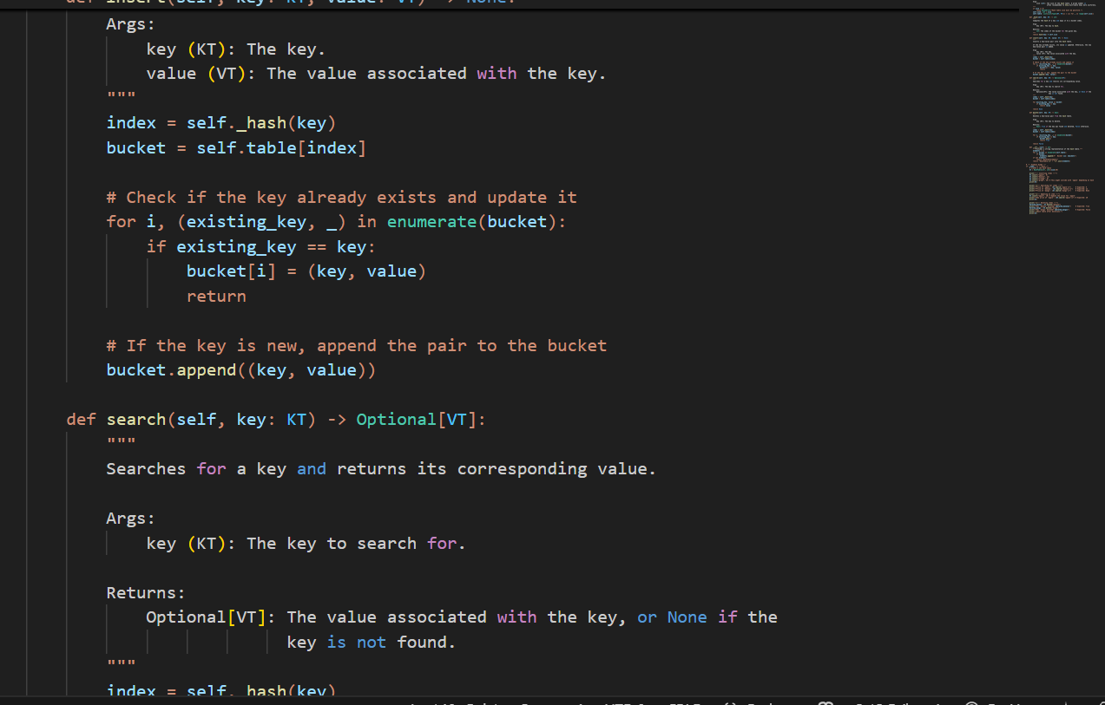

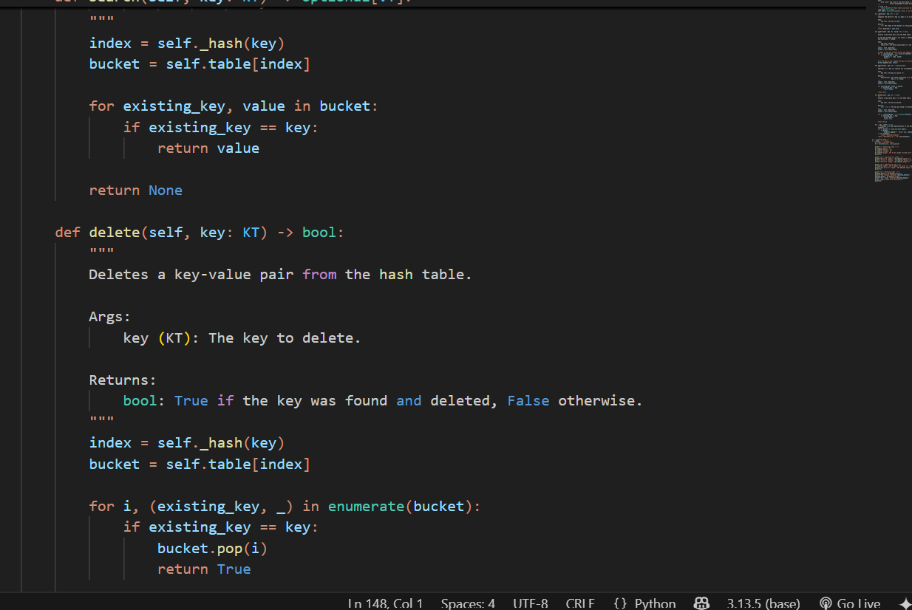

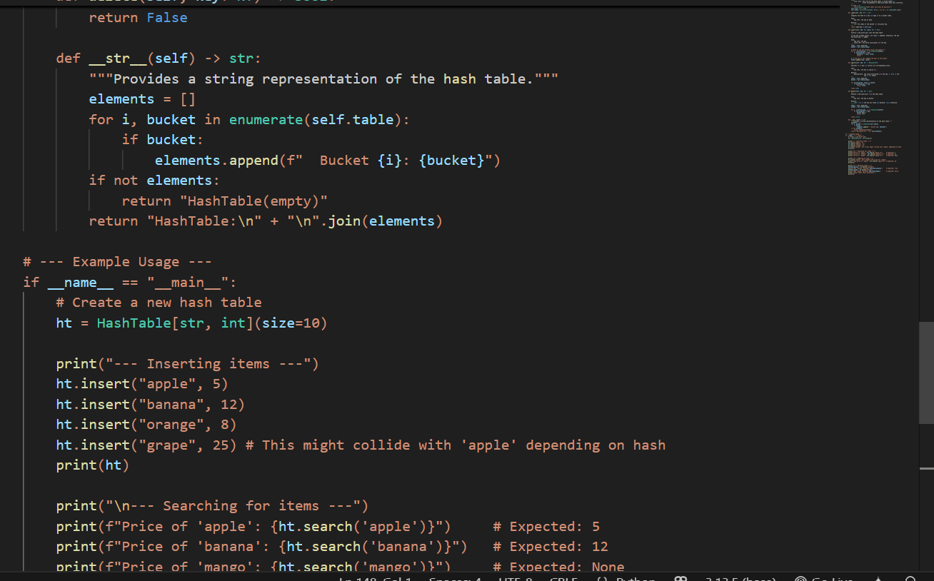

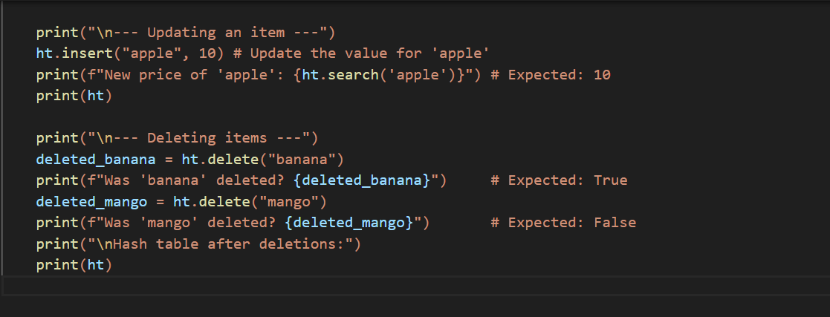

**Output:**

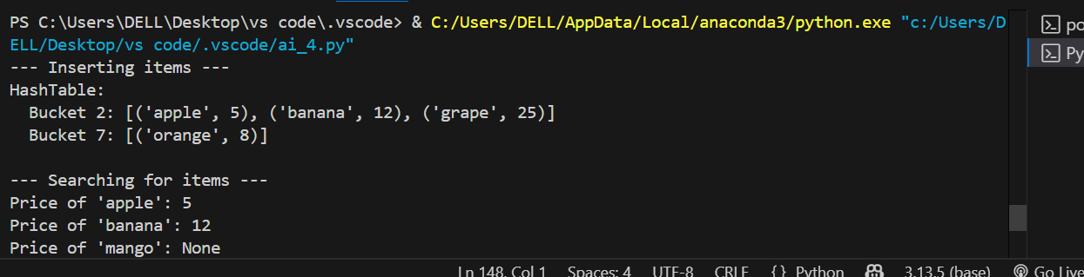

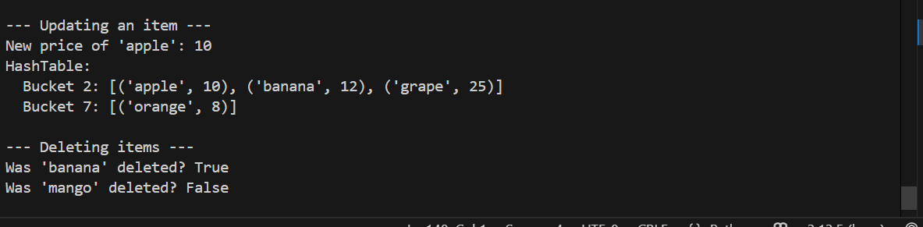

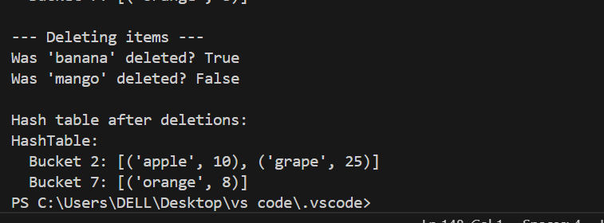

**Observations:**

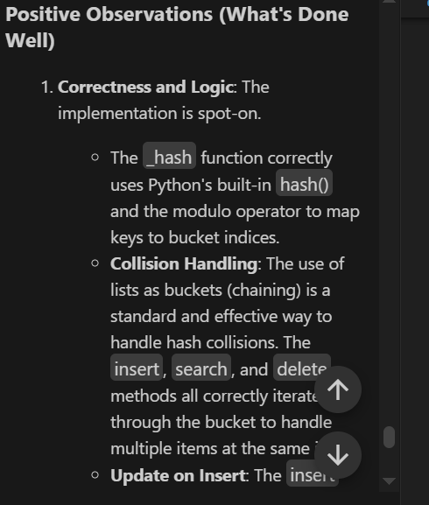

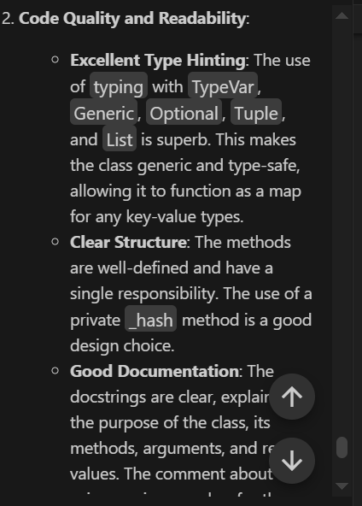

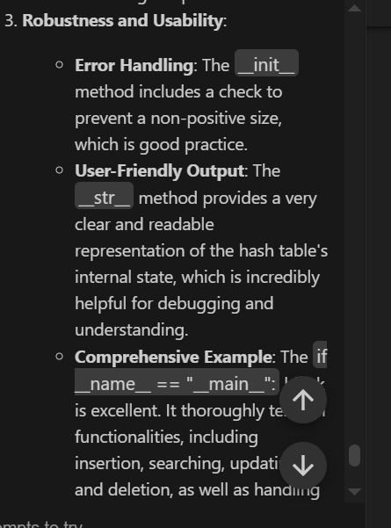

**Task Description #6** –

Graph Representation  
Task: Use AI to implement a graph using an adjacency list.  
Sample Input Code:  
class Graph:  
pass  
Expected Output:  
• Graph with methods to add vertices, add edges, and display  
connections

**PROMPT:**

implement a graph using an adjacency list.

**Code:**

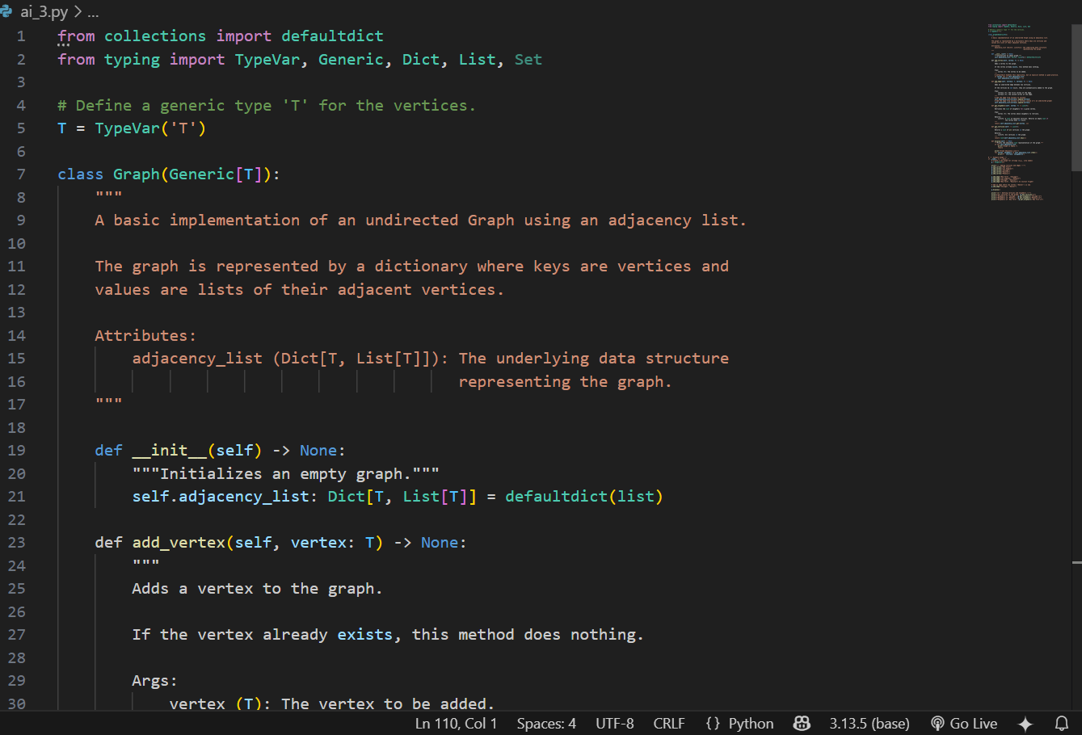

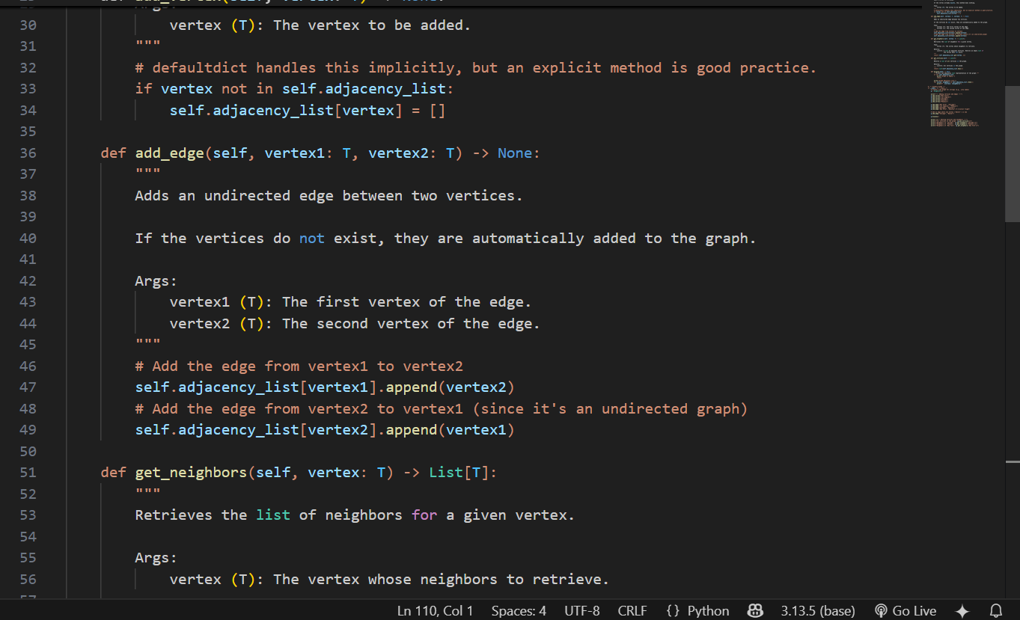

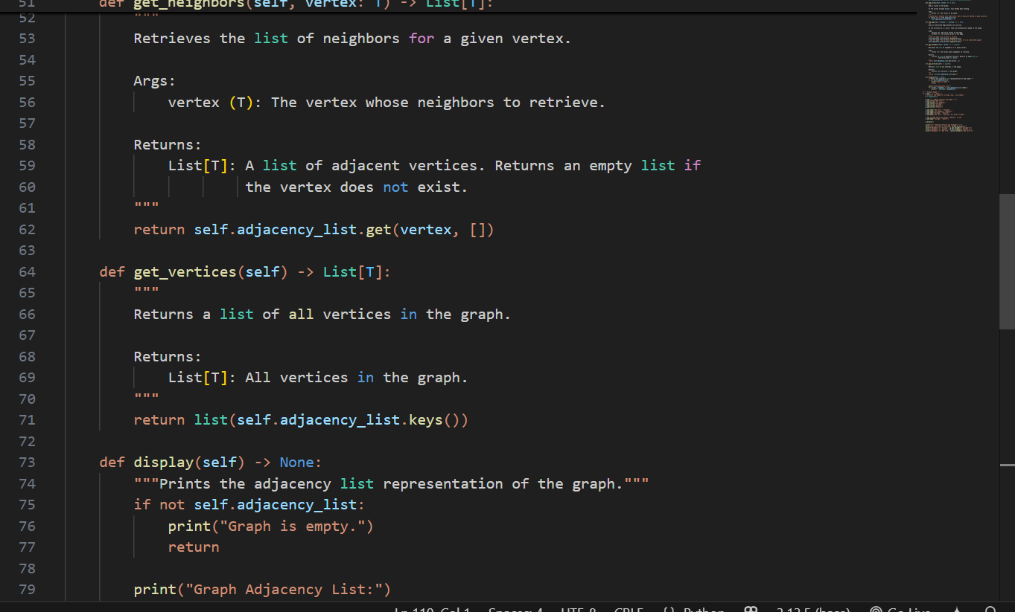

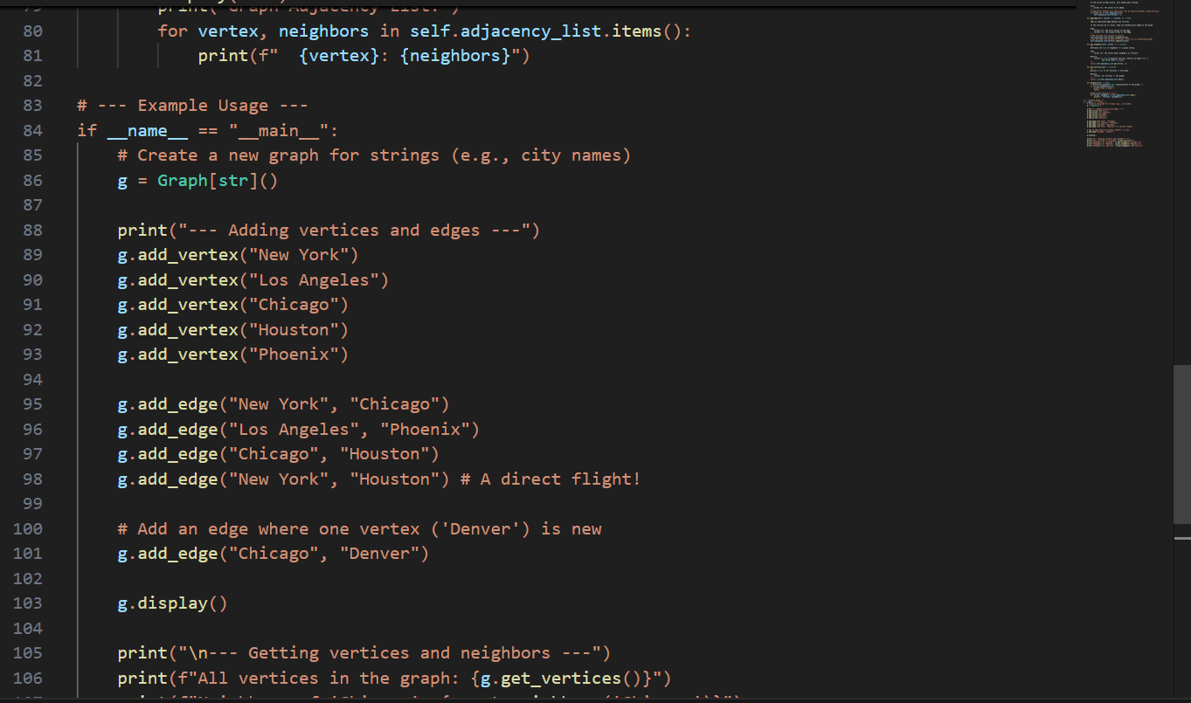

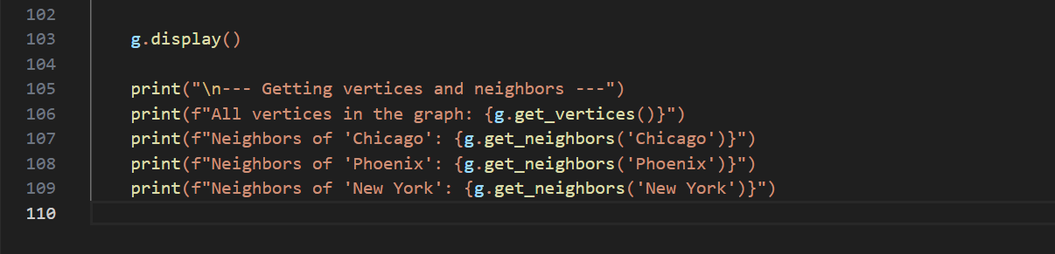

**Output:**

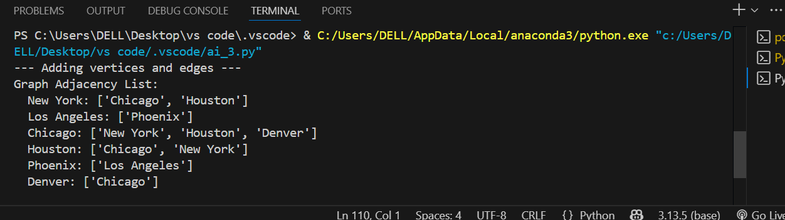

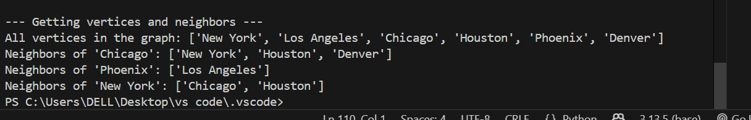

**Observations:**

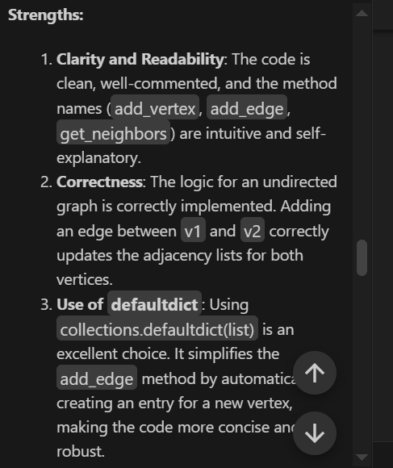

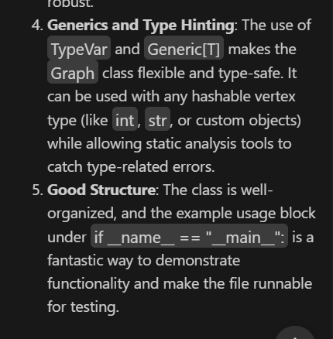

.  
**Task Description #7** –

Priority Queue  
Task: Use AI to implement a priority queue using Python’s heapq module.  
Sample Input Code:  
class PriorityQueue:  
pass  
Expected Output:  
• Implementation with enqueue (priority), dequeue (highest priority), and  
display methods.

**Prompt:**

implement a priority queue using Python’s heapq module.

**Code:**

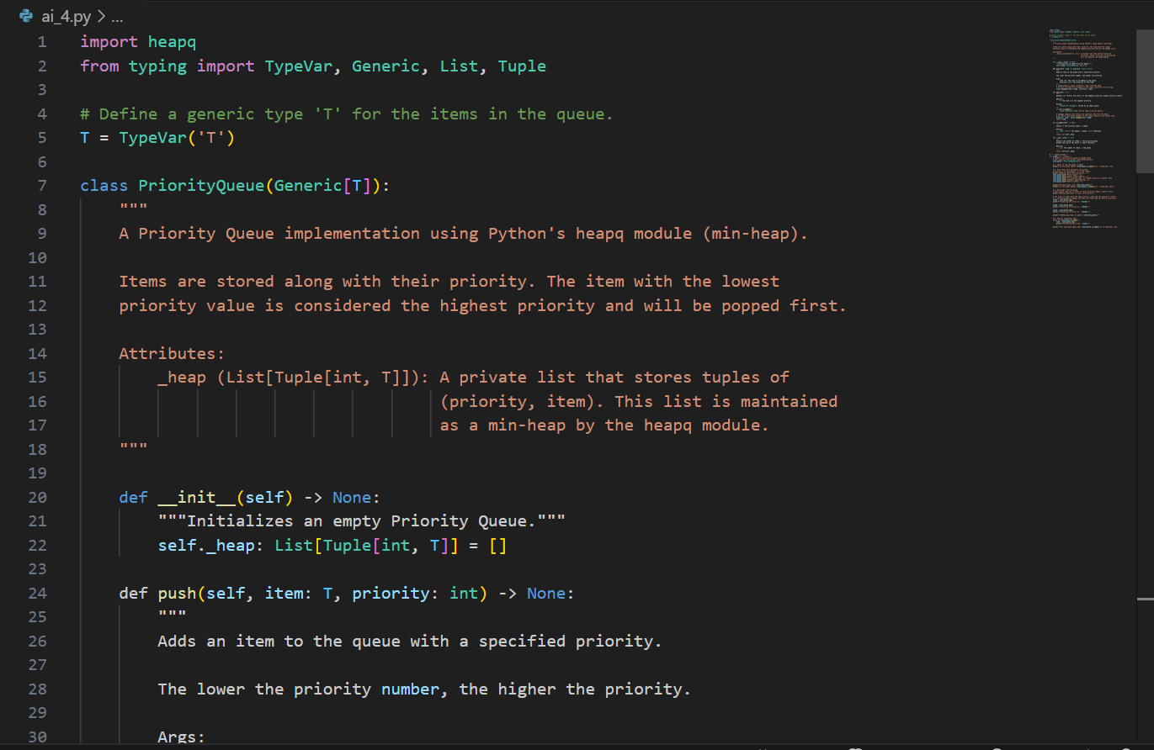

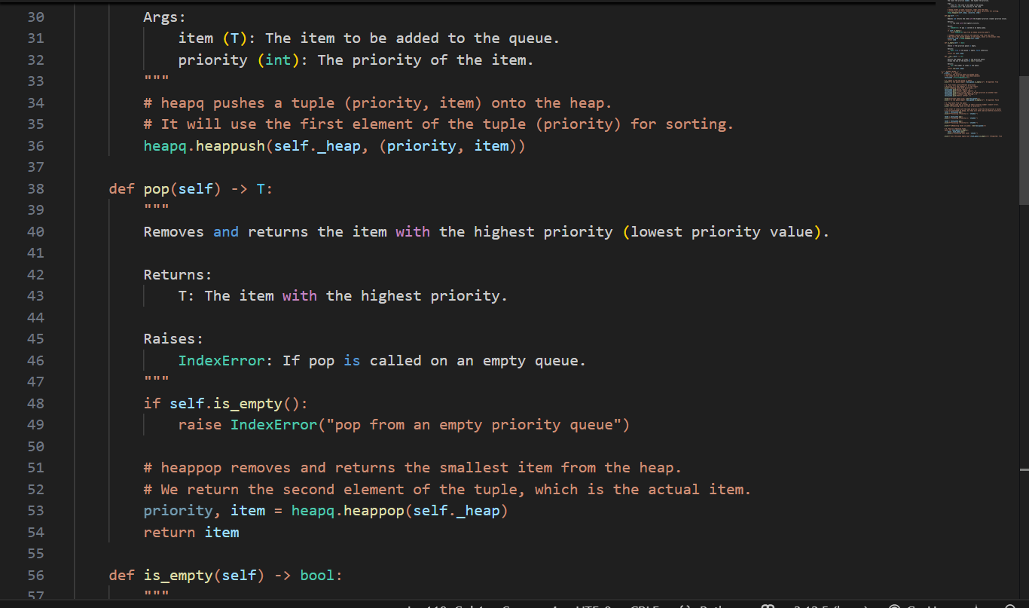

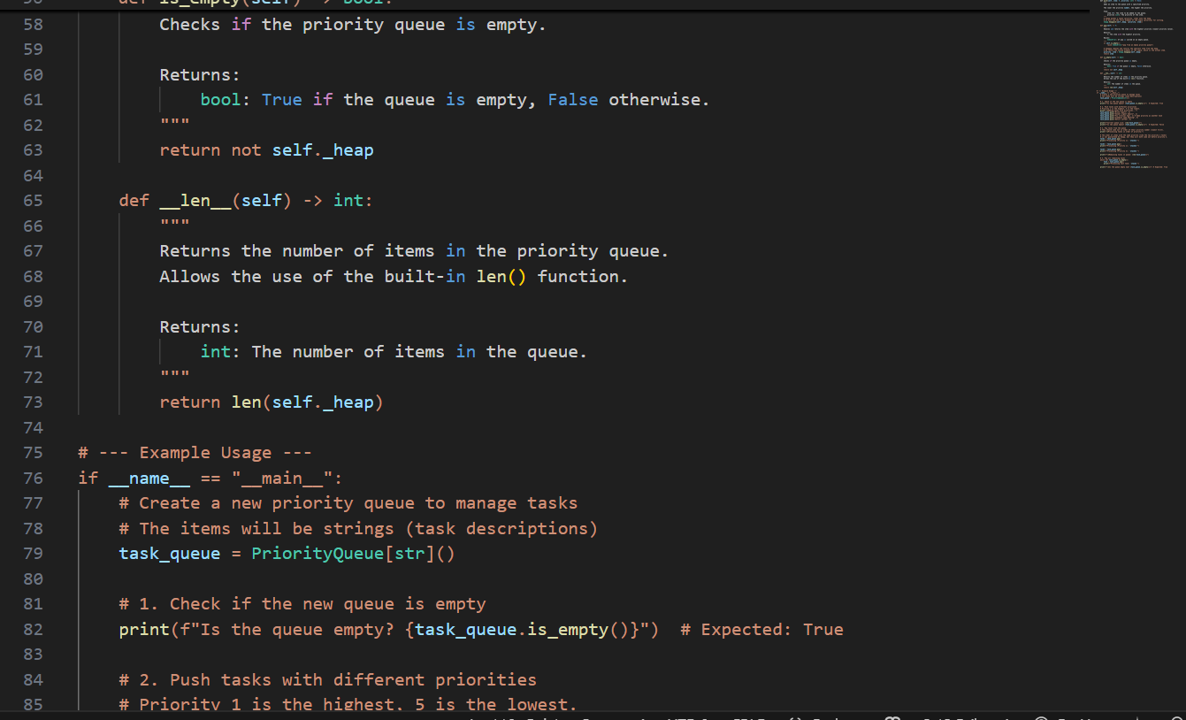

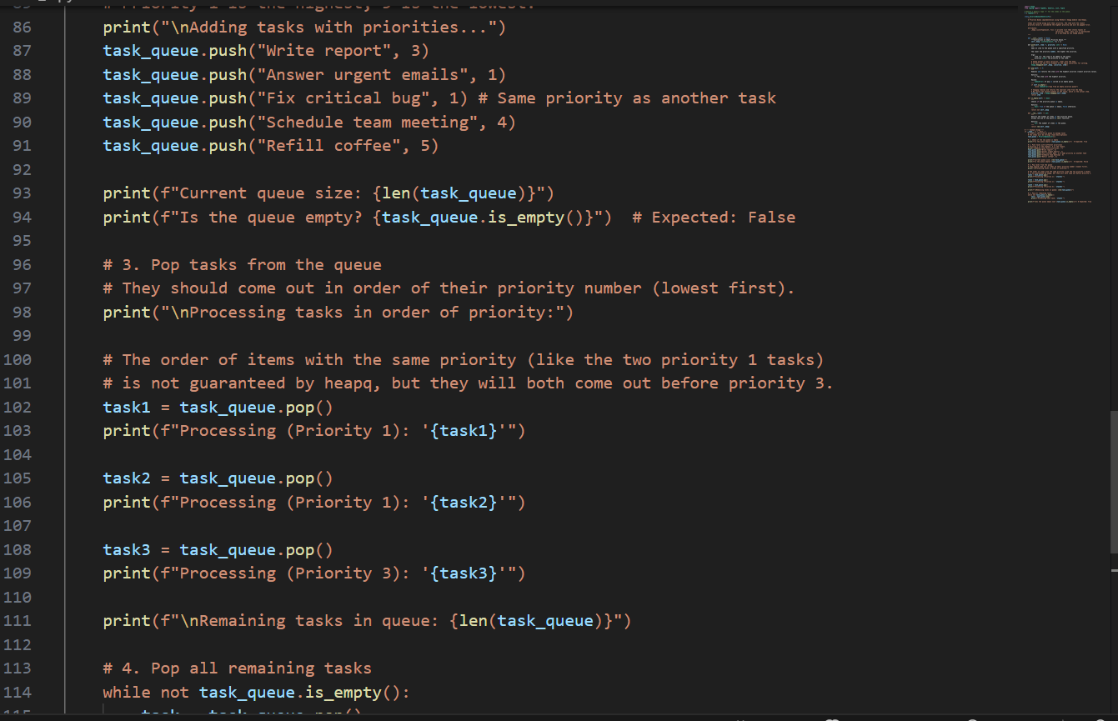

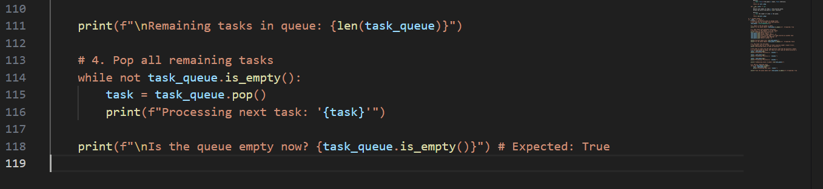

**Output:**

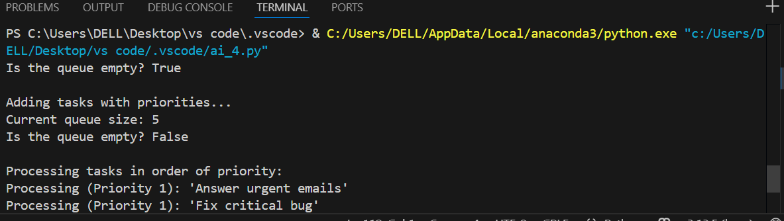

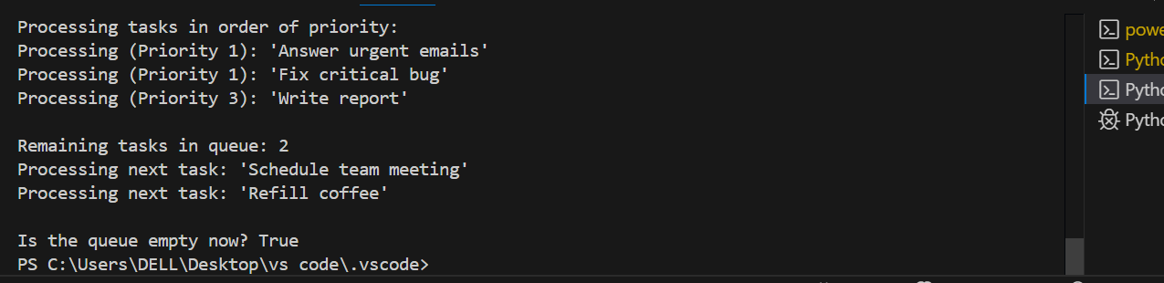

**Observations:**

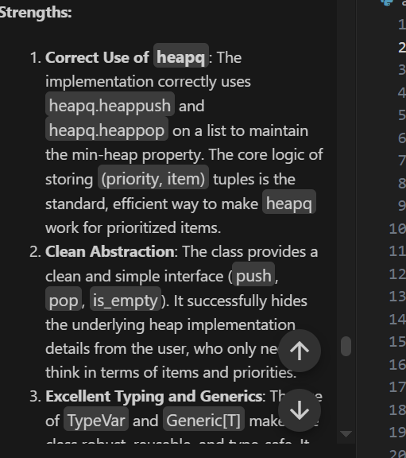

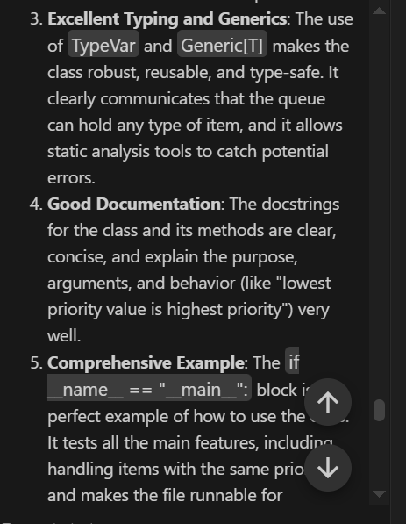

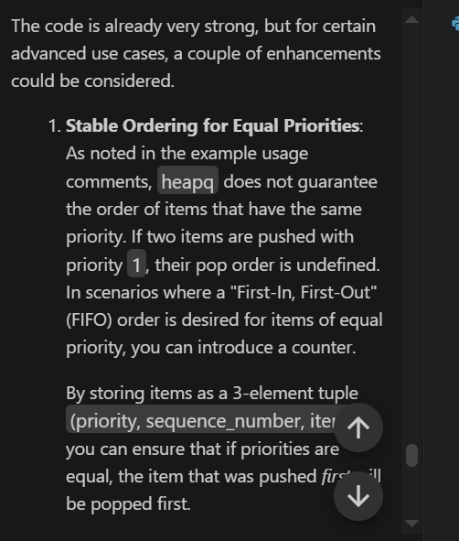

**Task Description #8** –

Deque  
Task: Use AI to implement a double-ended queue using collections.deque.  
Sample Input Code:  
class DequeDS:  
pass  
Expected Output:  
• Insert and remove from both ends with docstrings.

**Prompt:** implement a double-ended queue using collections.deque

**Code:**

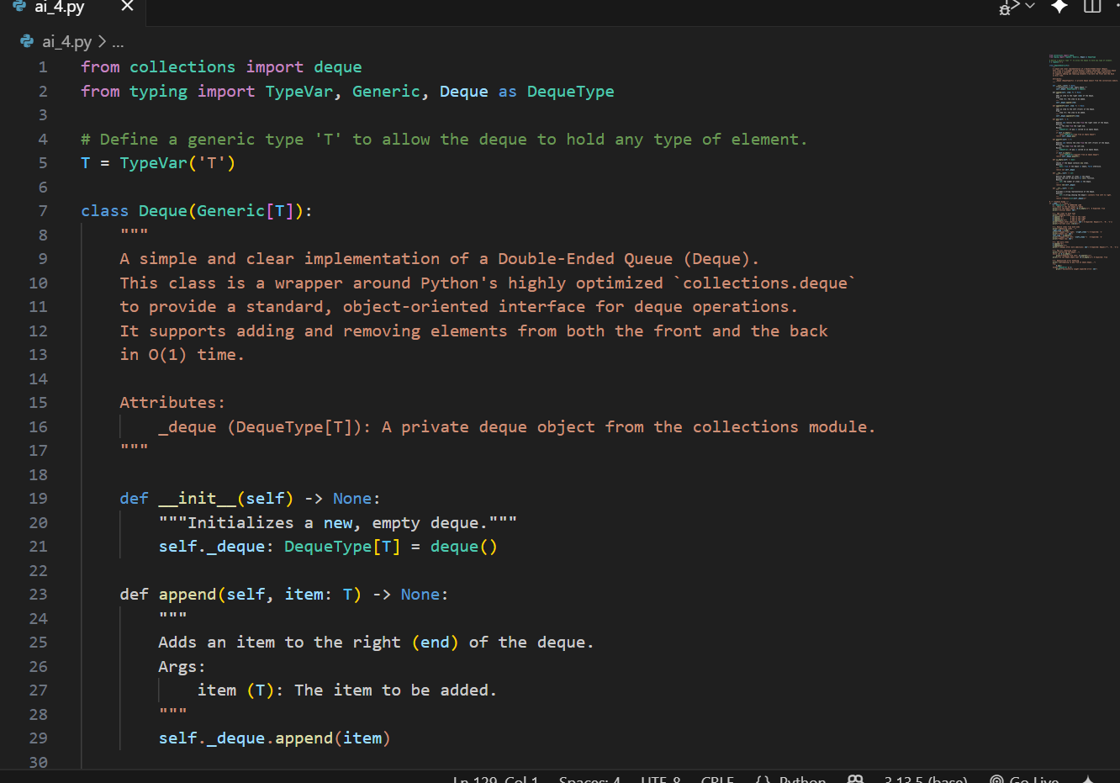

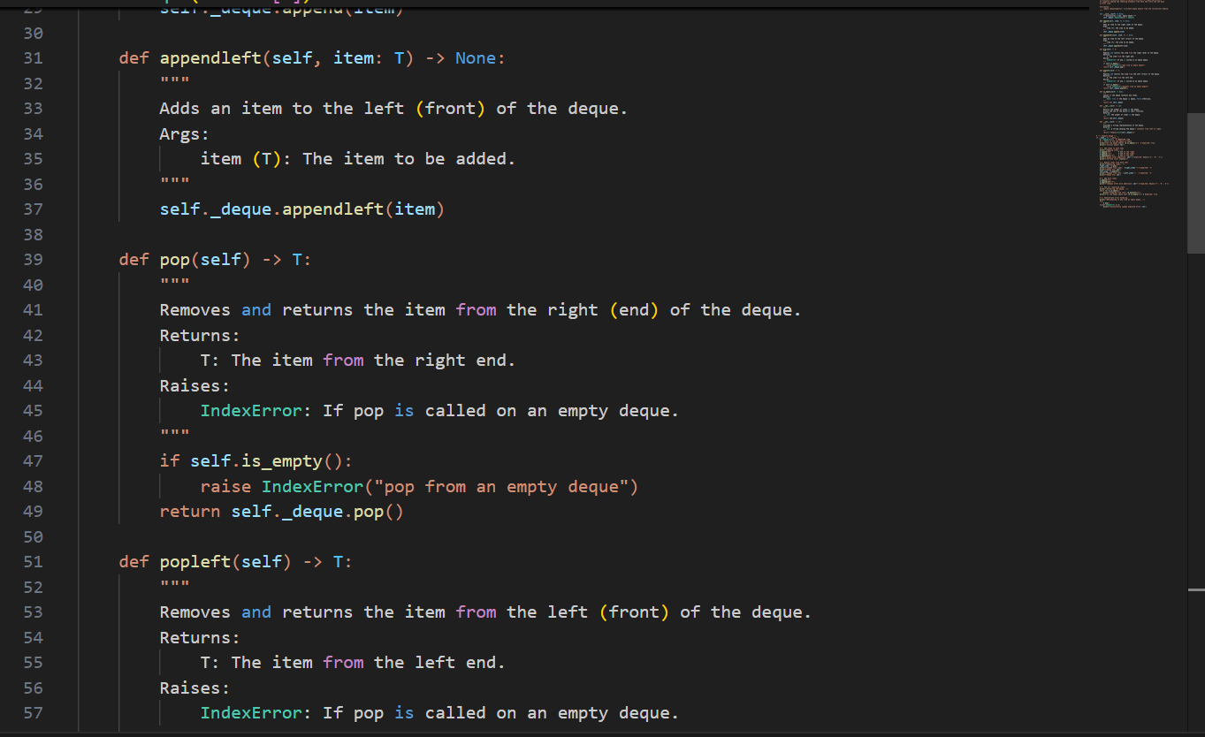

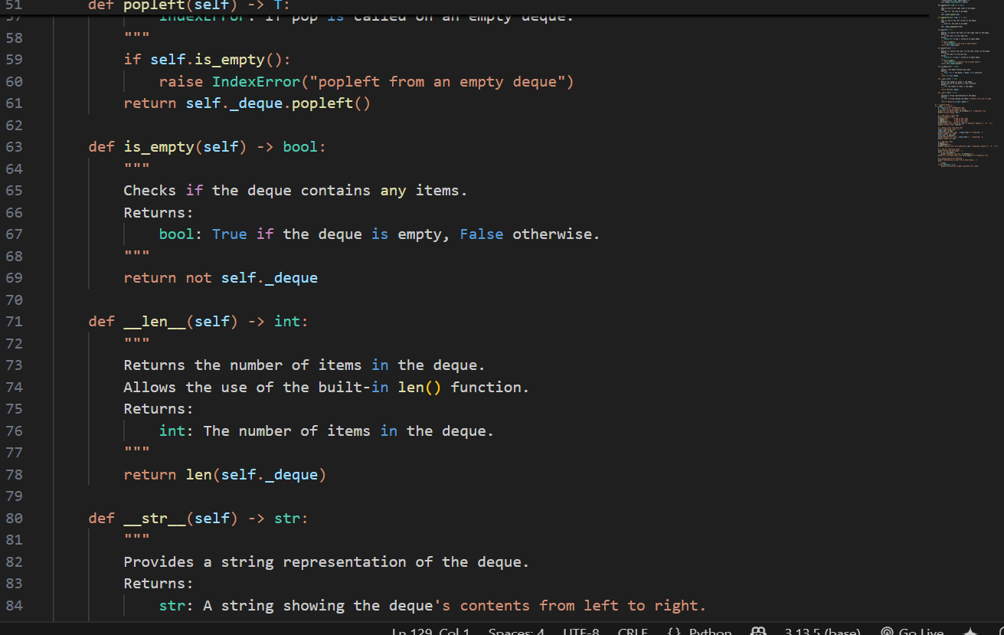

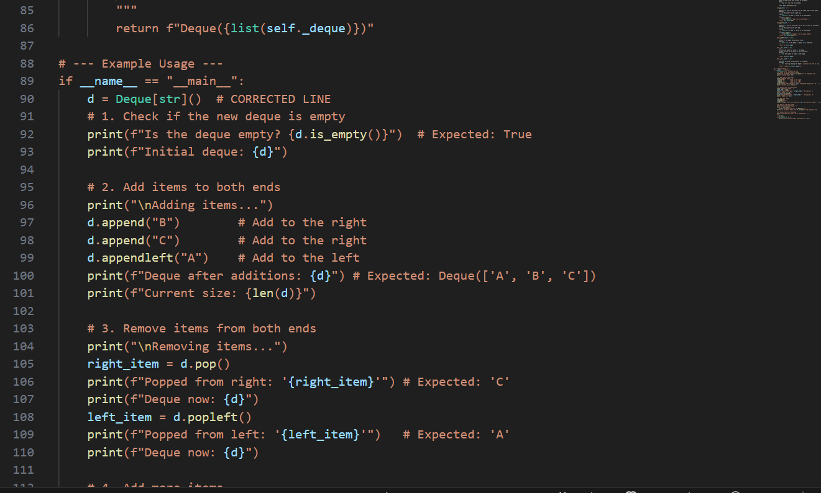

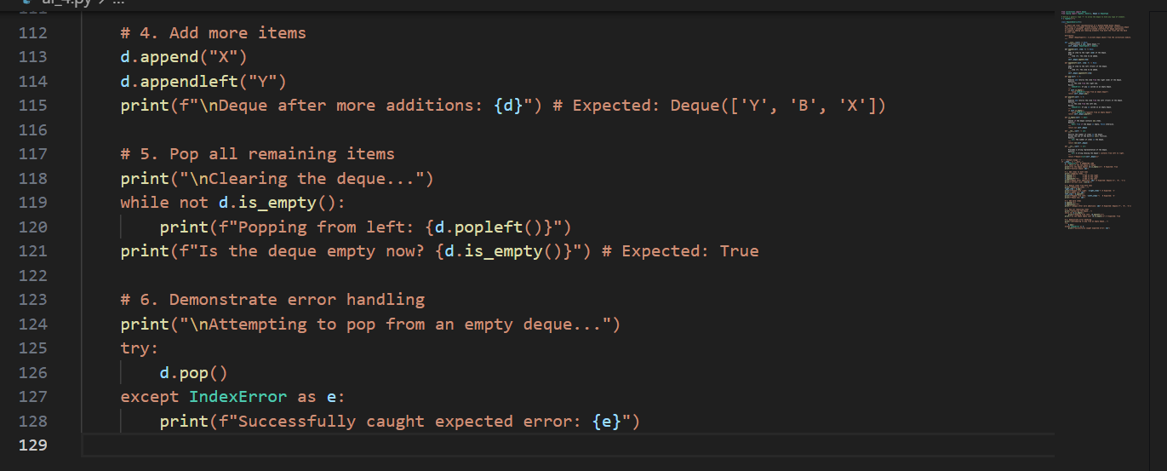

**Output:**

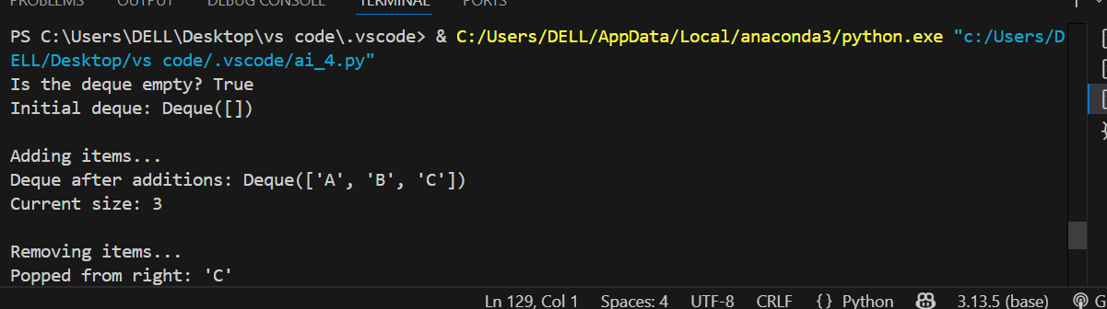

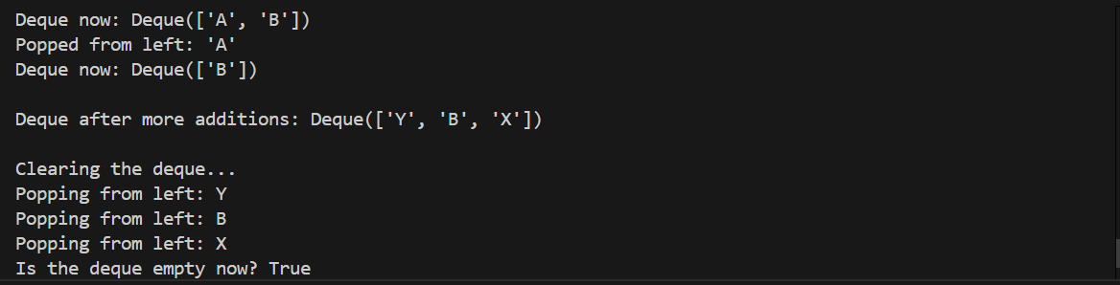

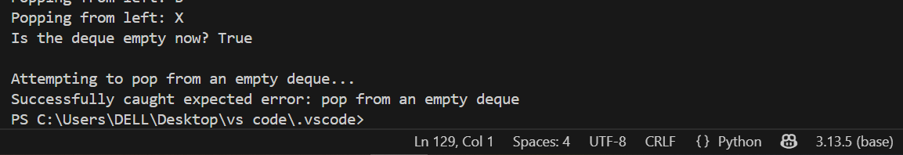

**Observations:**

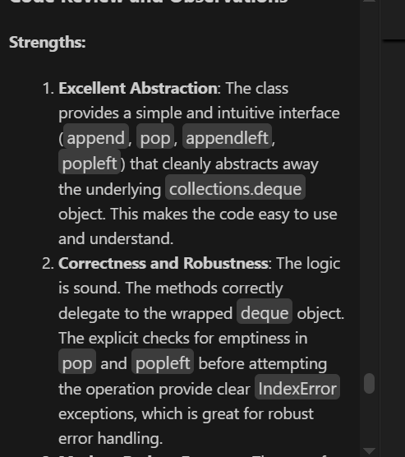

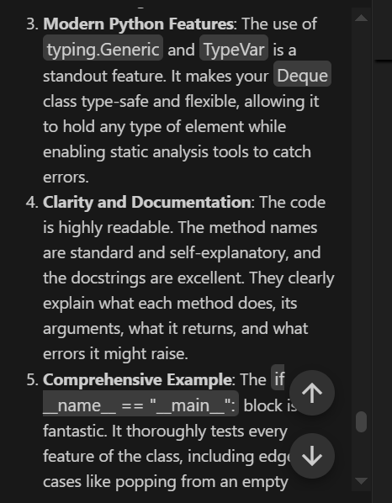

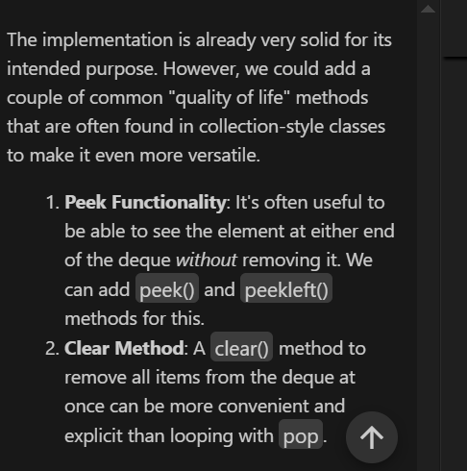

**Task Description #9** –

AI-Generated Data Structure Comparisons  
Task: Use AI to generate a comparison table of different data structures (stack,  
queue, linked list, etc.) including time complexities.  
Sample Input Code:  
# No code, prompt AI for a data structure comparison table  
Expected Output:  
• A markdown table with structure names, operations, and complexities.

**Prompt:**

generate a comparison table of different data structures (stack,  
queue, linked list, etc.) including time complexities.

**Code:**

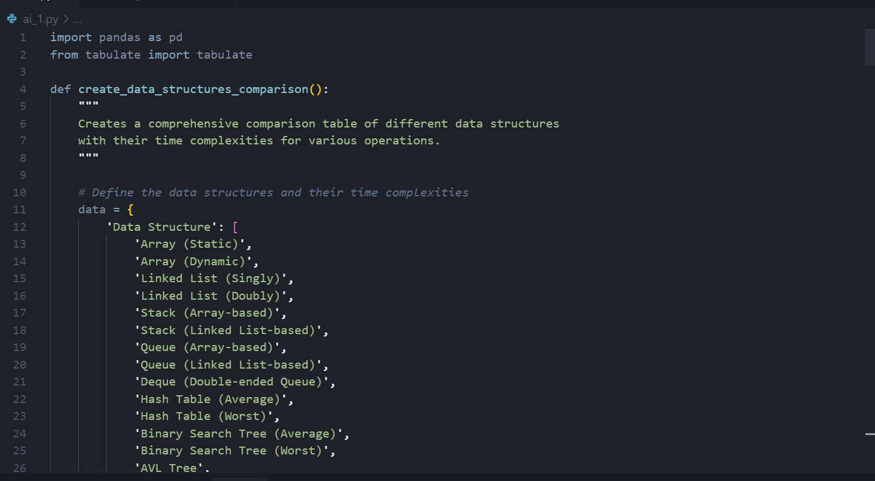

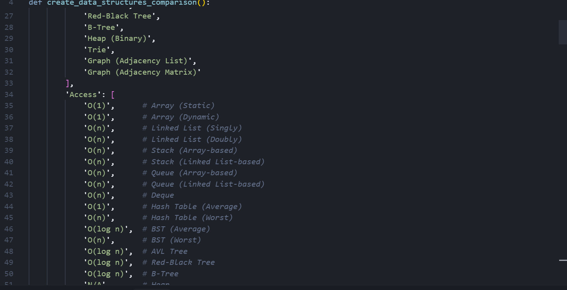

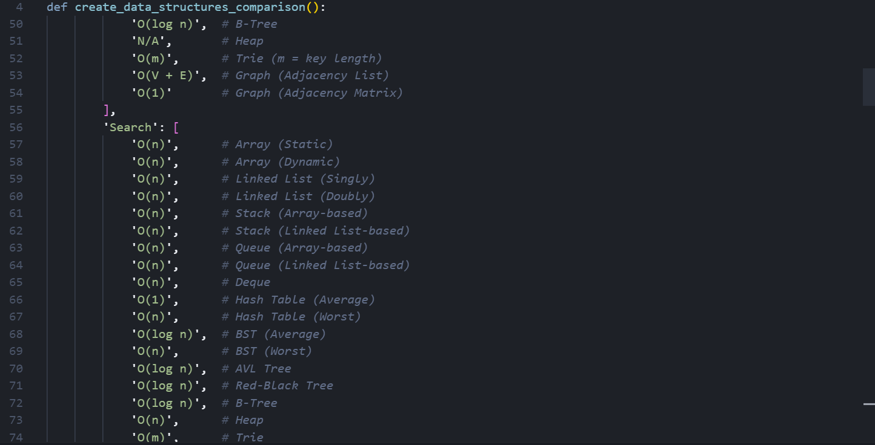

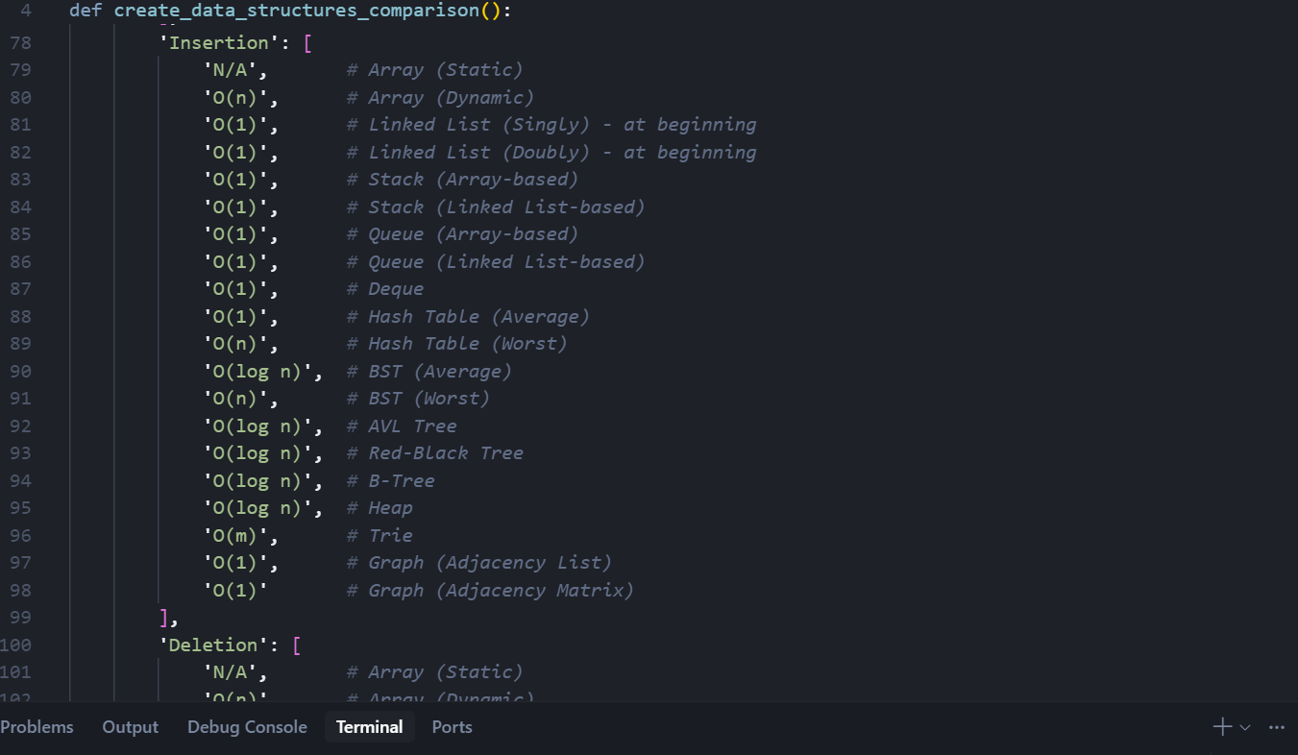

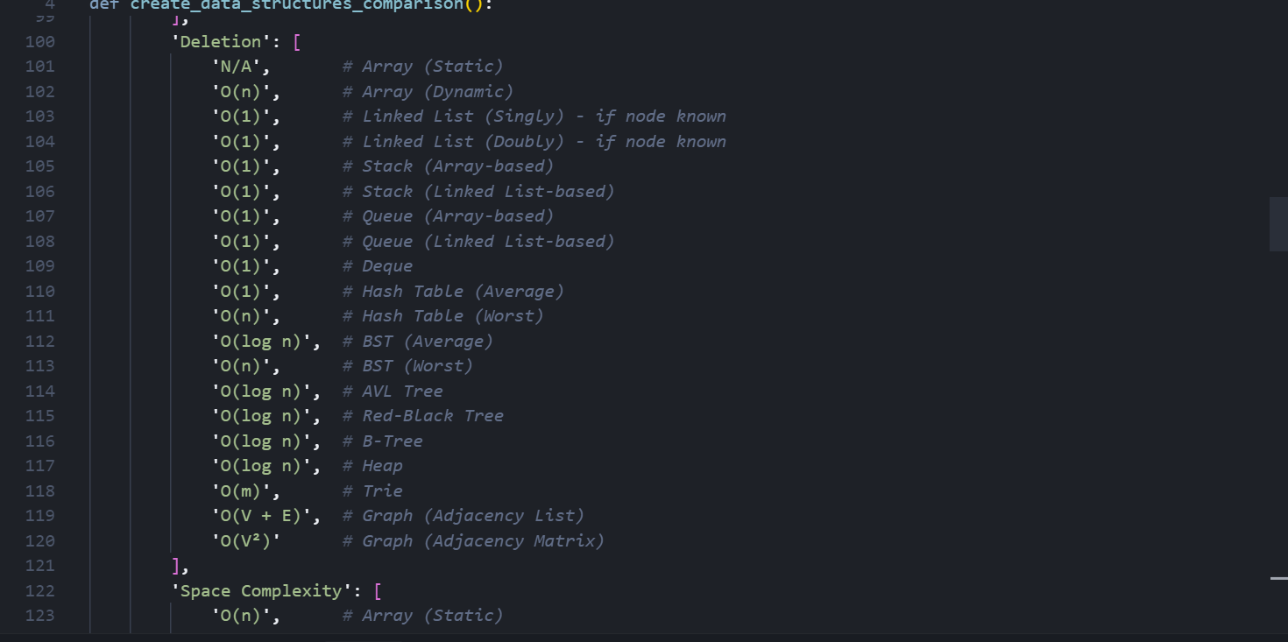

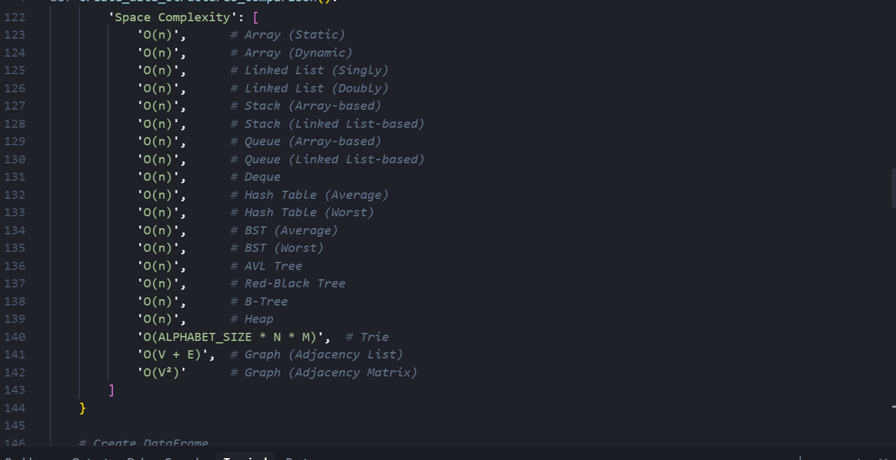

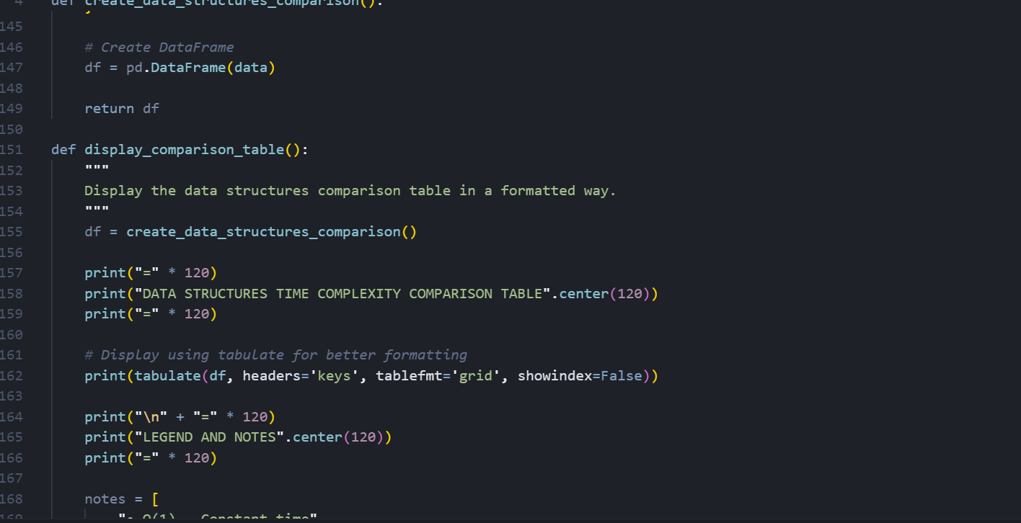

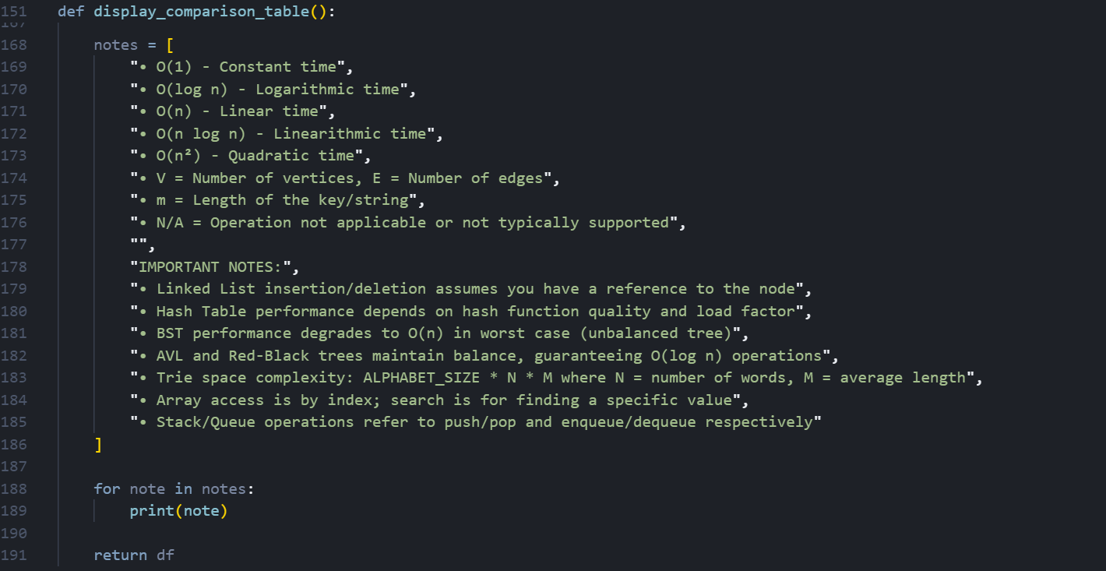

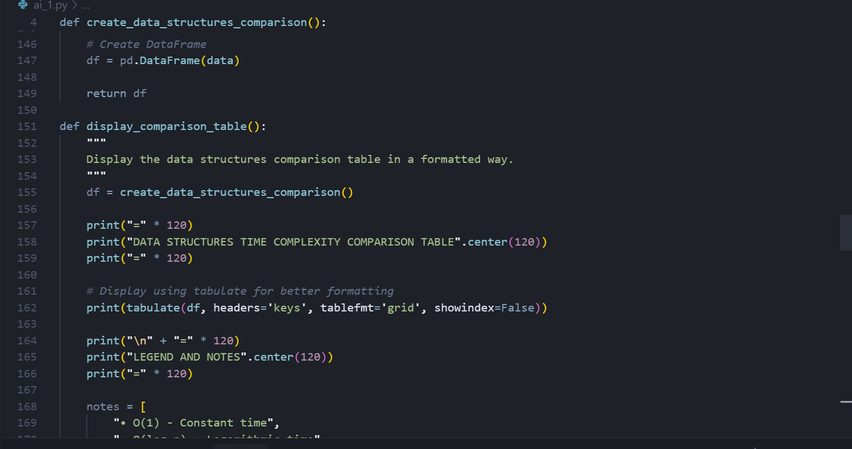

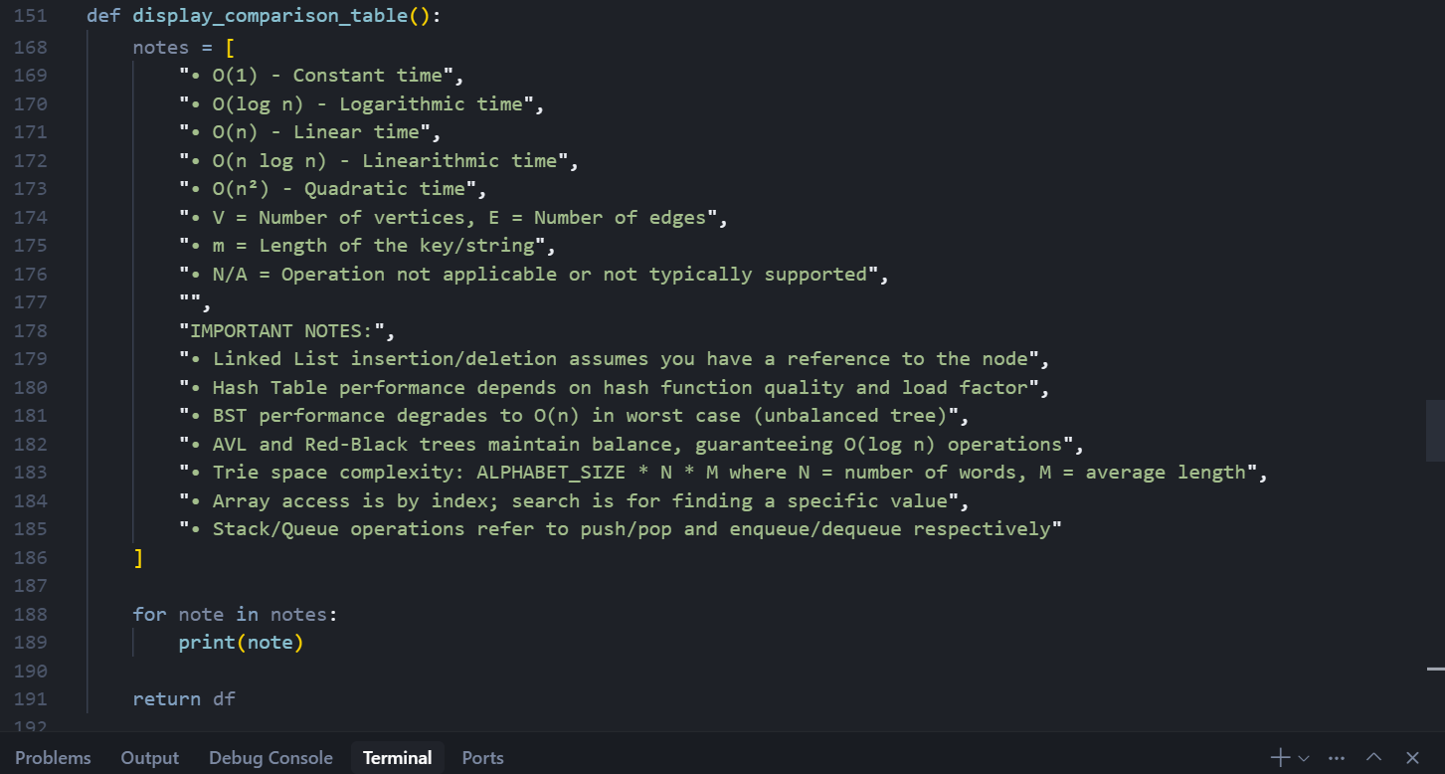

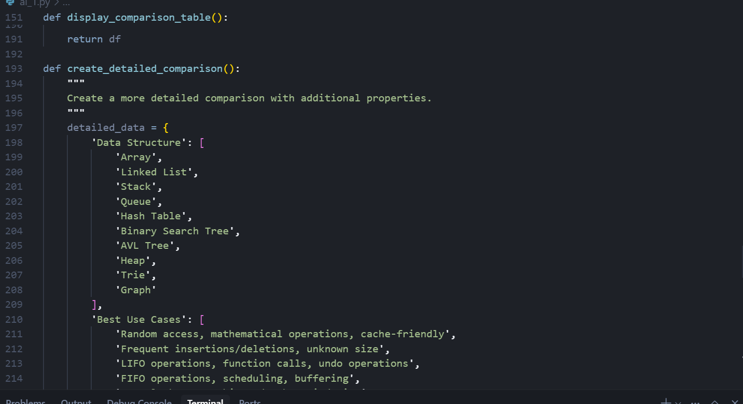

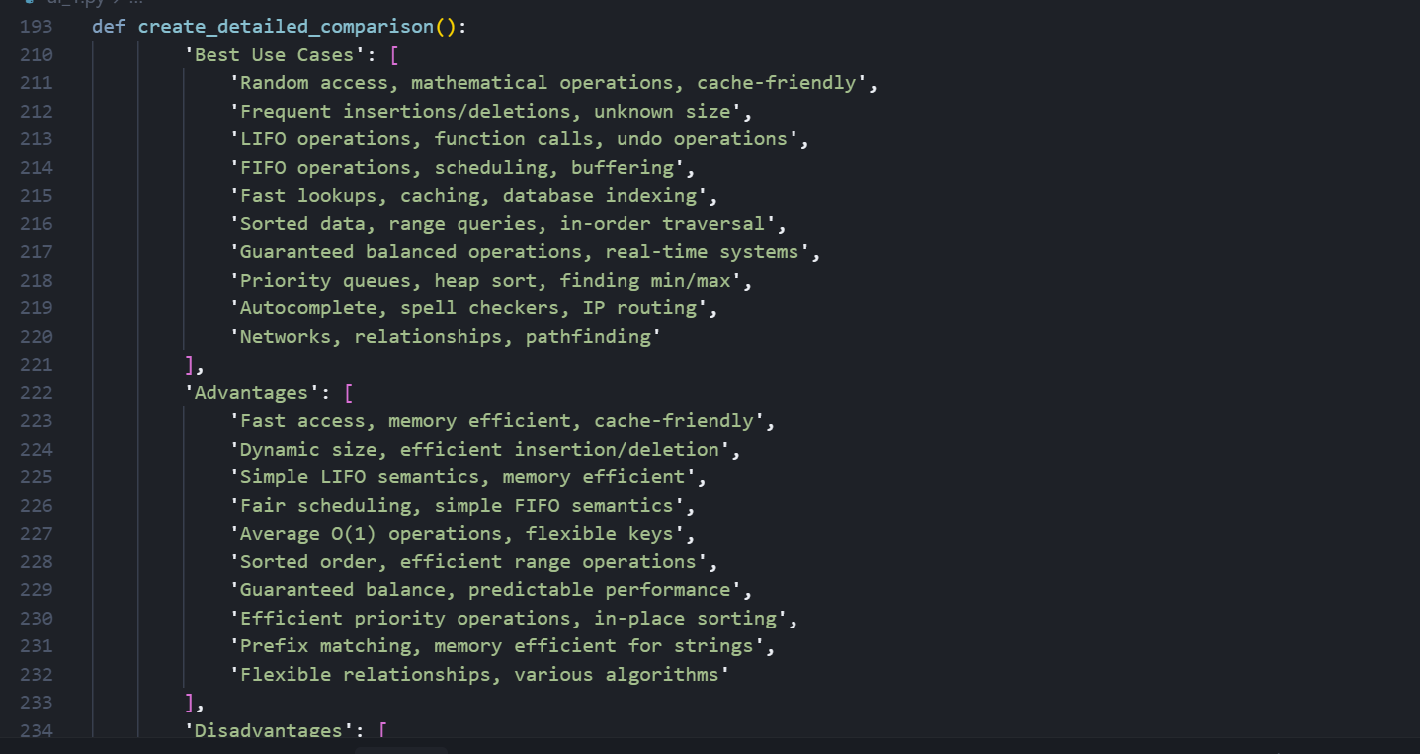

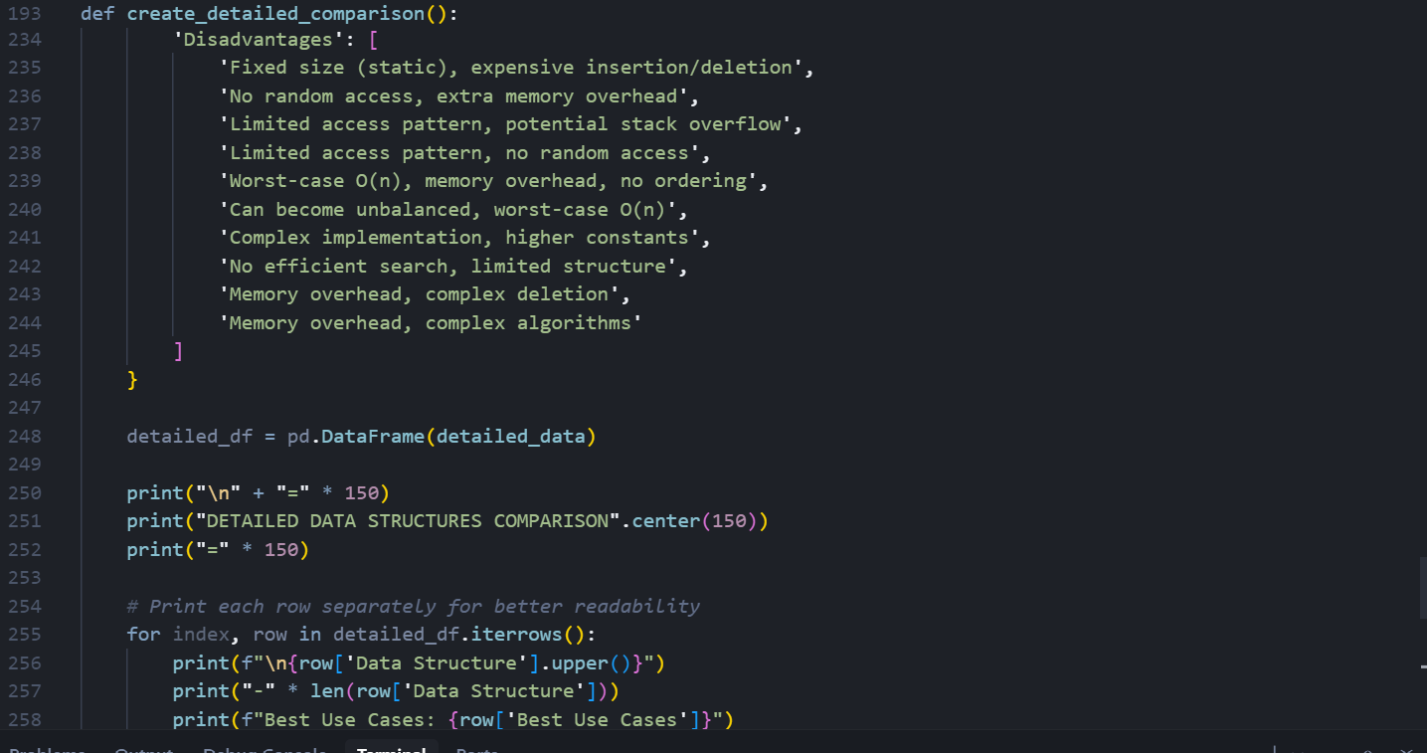

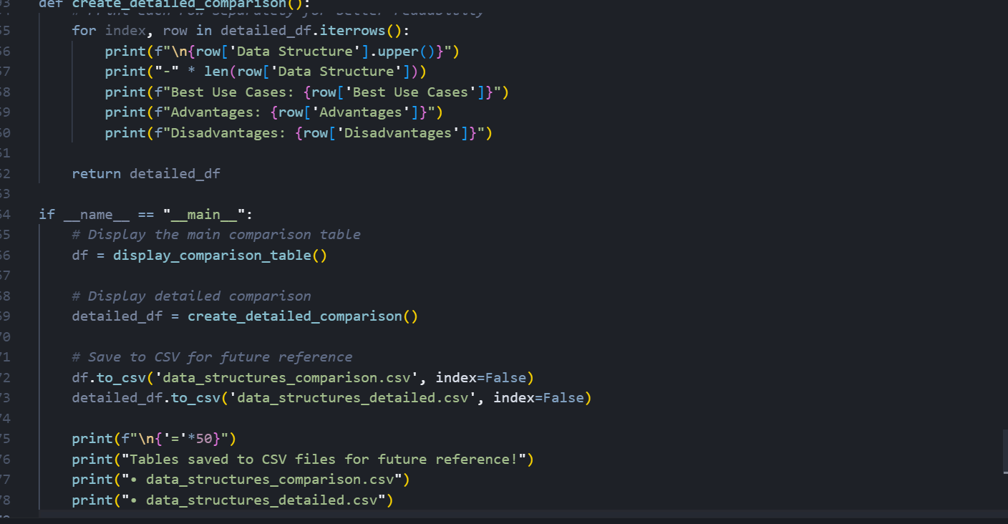

**Output:**

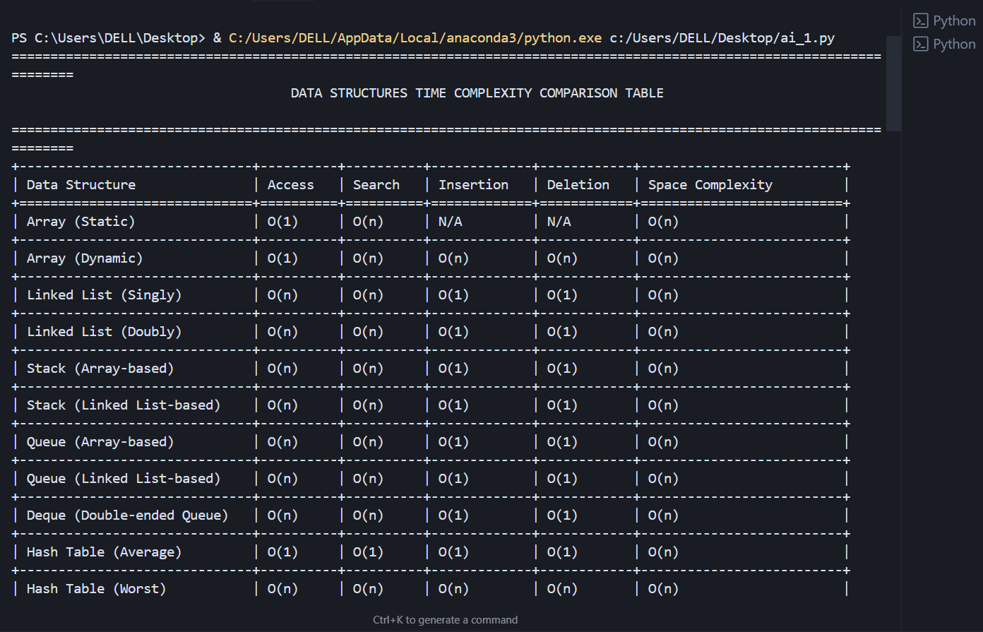

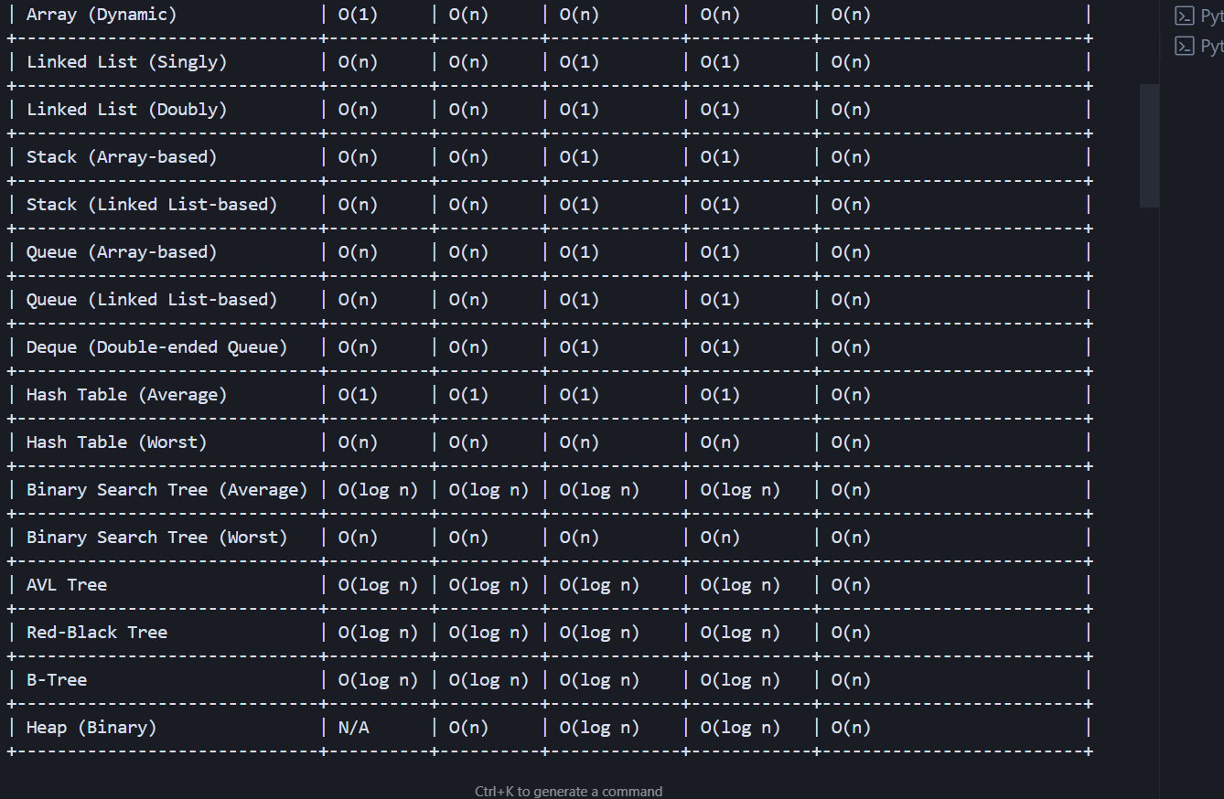

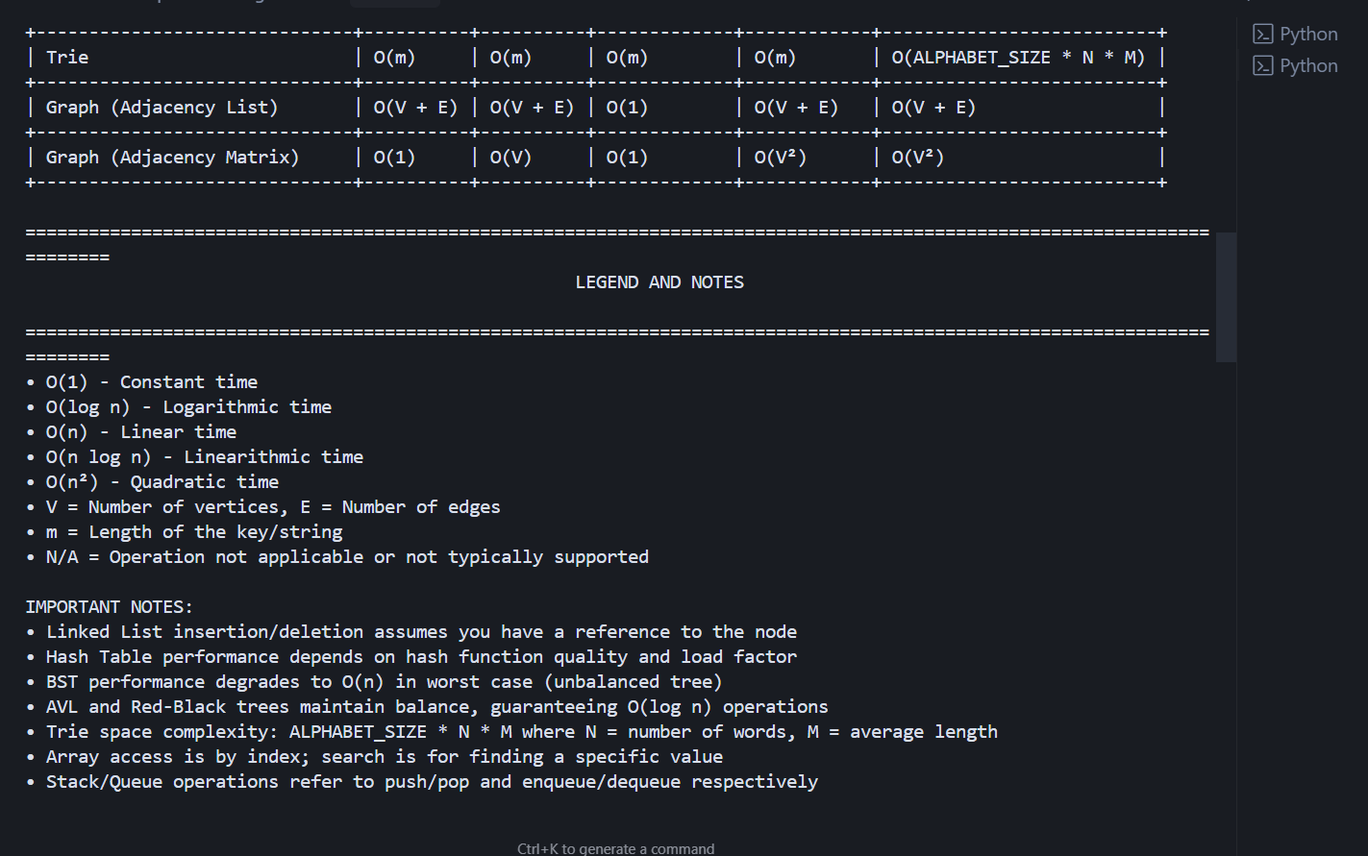

**Observations:**

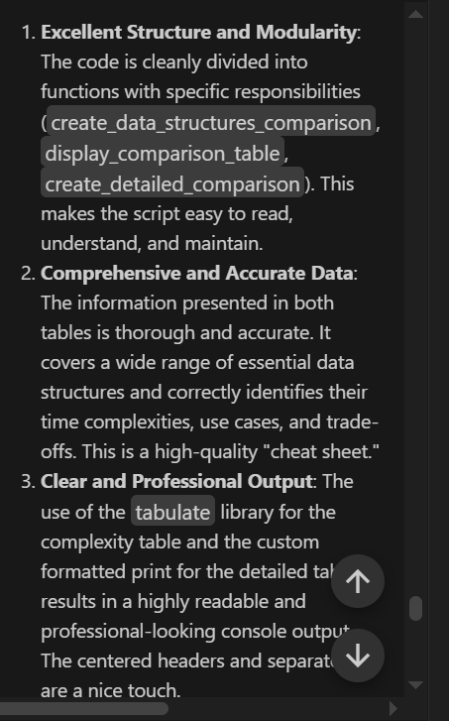

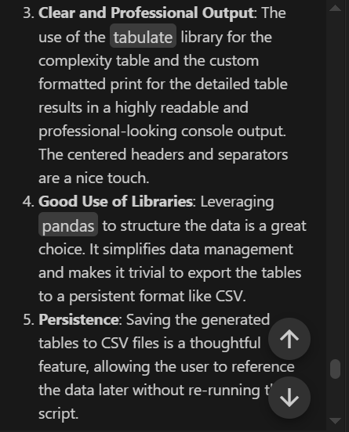

**Task Description #10**

Real-Time Application Challenge – Choose the  
Right Data Structure  
Scenario:

Your college wants to develop a Campus Resource Management System that  
handles:  
1. Student Attendance Tracking – Daily log of students entering/exiting  
the campus.  
2. Event Registration System – Manage participants in events with quick  
search and removal.  
3. Library Book Borrowing – Keep track of available books and their due  
dates.  
4. Bus Scheduling System – Maintain bus routes and stop connections.  
5. Cafeteria Order Queue – Serve students in the order they arrive.  
Student Task:  
• For each feature, select the most appropriate data structure from the list  
below:  
o Stack  
o Queue  
o Priority Queue  
o Linked List  
o Binary Search Tree (BST)  
o Graph  
o Hash Table  
o Deque

• Justify your choice in 2–3 sentences per feature.  
• Implement one selected feature as a working Python program with AI-  
assisted code generation.  
Expected Output:  
• A table mapping feature → chosen data structure → justification.  
• A functional Python program implementing the chosen feature with  
comments and docstrings.

**Prompt:**

Your college wants to develop a Campus Resource Management System that  
handles:  
1. Student Attendance Tracking – Daily log of students entering/exiting  
the campus.  
2. Event Registration System – Manage participants in events with quick  
search and removal.  
3. Library Book Borrowing – Keep track of available books and their due  
dates.  
4. Bus Scheduling System – Maintain bus routes and stop connections.  
5. Cafeteria Order Queue – Serve students in the order they arrive.  
Student Task:  
• For each feature, select the most appropriate data structure from the list  
below:  
o Stack  
o Queue  
o Priority Queue  
o Linked List  
o Binary Search Tree (BST)  
o Graph  
o Hash Table  
o Deque

**Code:**

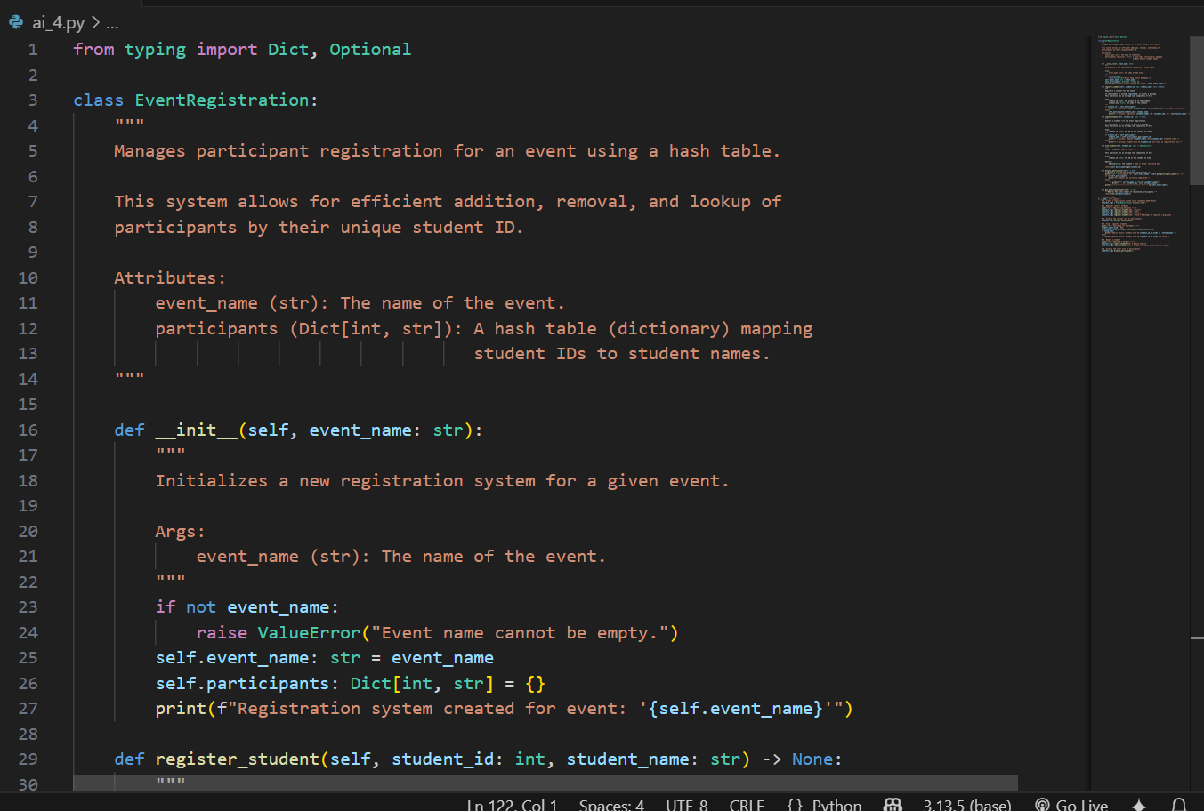

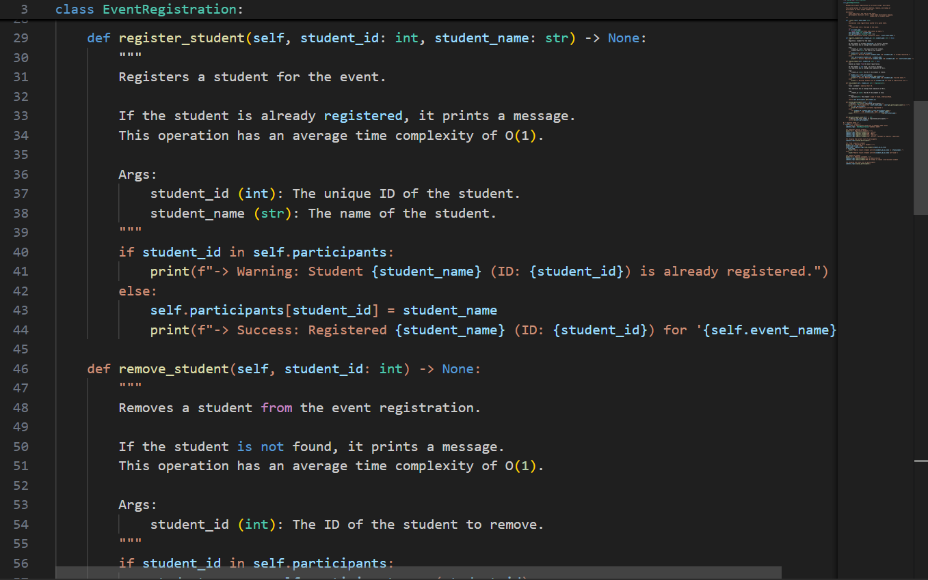

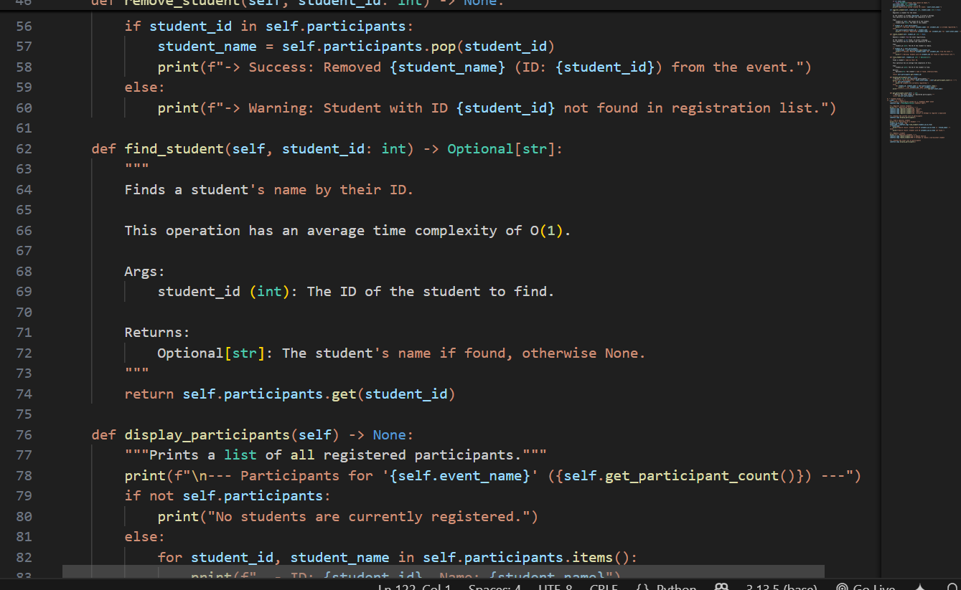

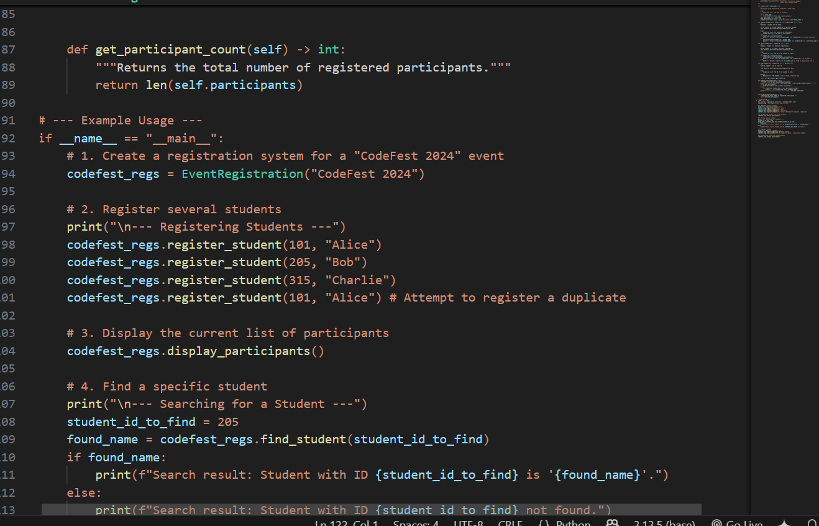

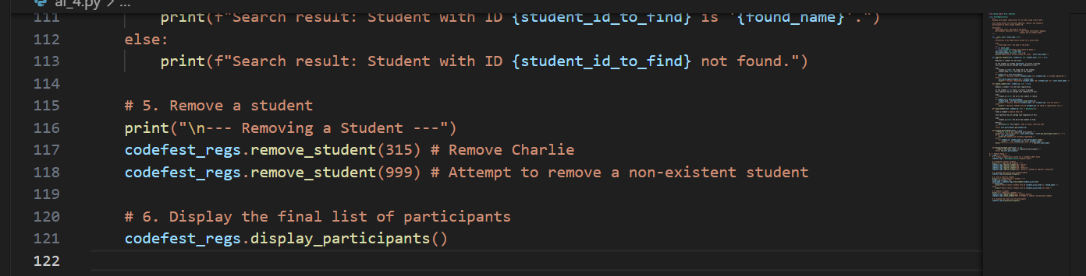

**Output:**

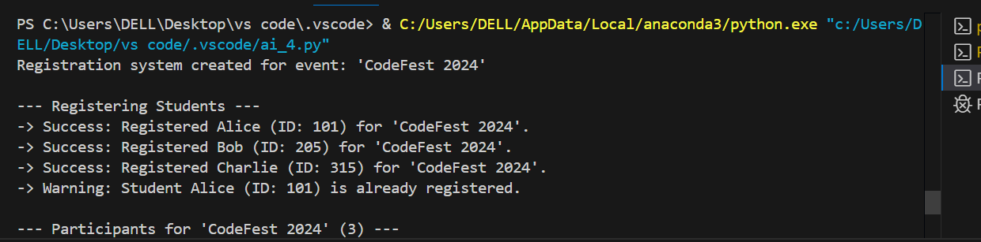

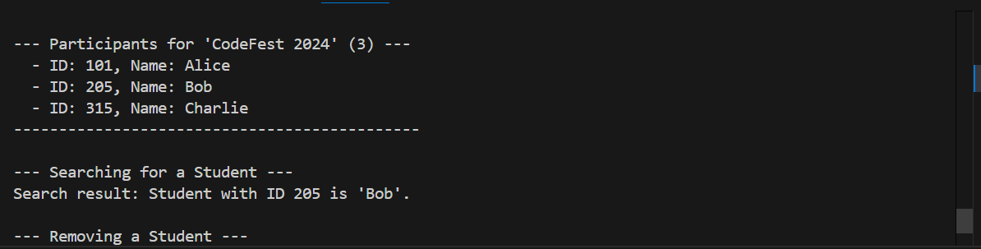

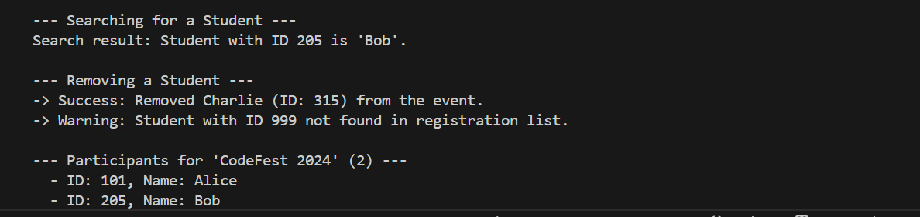

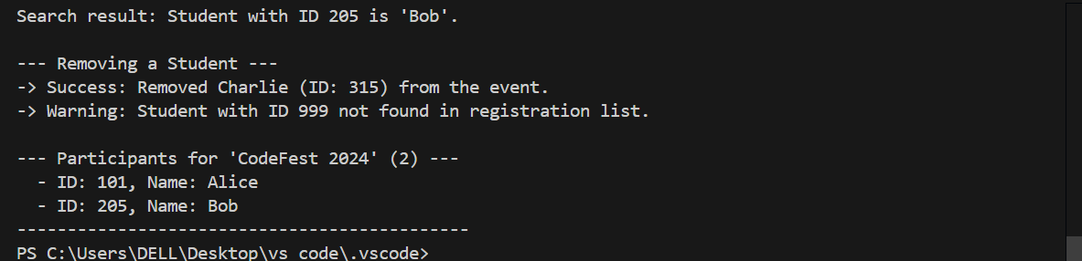

**Observations:**

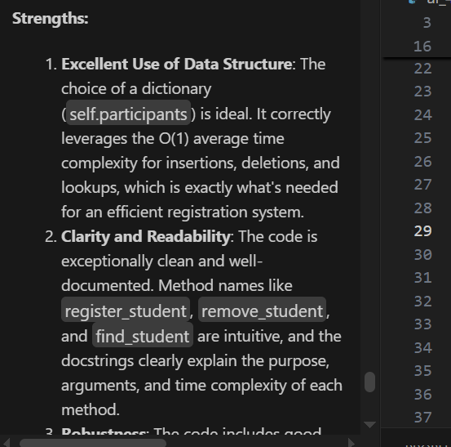

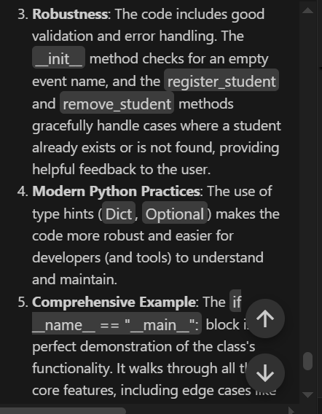

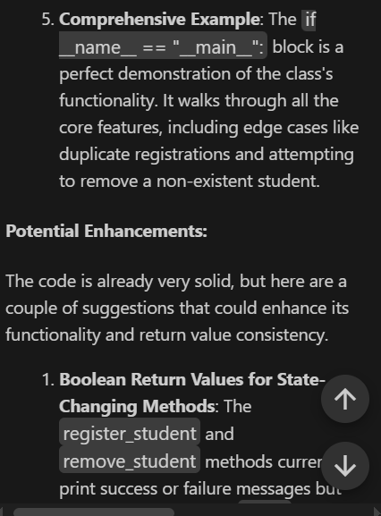

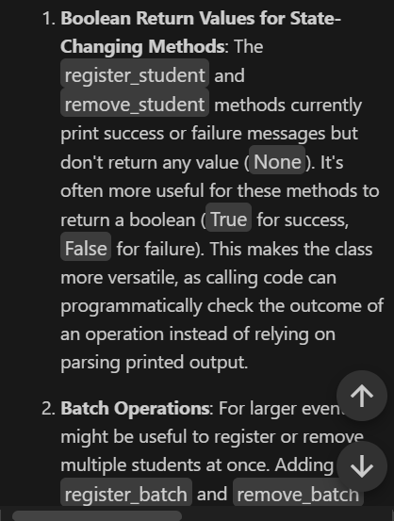

**Deliverables (For All Tasks)**  
1. AI-generated prompts for code and test case generation.  
2. At least 3 assert test cases for each task.  
3. AI-generated initial code and execution screenshots.  
4. Analysis of whether code passes all tests.  
5. Improved final version with inline comments and explanation.  
6. Compiled report (Word/PDF) with prompts, test cases, assertions, code,  
and output